

goAML Schema 5.0.1

Standard XML Reporting

25 February 2022

**Revision History**

|  |  |  |  |
| --- | --- | --- | --- |
| **Rev** | **Date** | **Author** | **Description** |
| 2.1 | May 19, 2008 | T. Breineder | Combined STR and CTR schemas |
| 2.2 | June 04, 2008 | M Abu Ghali | Finalized version for the FIC Namibia |
| 2.3 | June 06, 2008 | T. Breineder | Moved local currency element from the transaction details to the report element |
| 2.4 | June 06, 2008 | T. Breineder | Amended account holder to include a flag specifying the primary signatory |
| 2.4.1 | June 23, 2008 | M. Abu Ghali | Account Balance element added to t_account node |
| 2.4.2 | July 30, 2008 | Ameen Safadi |  |
| 2.4.3 | August 28, 2008 | M. Zeeshan Tahir | Teller in Transaction was made optional. Differences between schema & documentation rectified. |
| 2.4.4 | August 29,2008 | Stefan Brezina | Consistency check and rework |
| 2.4.4 | September 12, 2008 | Ameen Safadi | Remove Entity Type lookup table from document, and clean some unused lookup values. No change in schema. |
| 2.4.5 | November 03, 2008 | Zeeshan Tahir | All date fields are bound to have values later than or equal to 1900-01-01 |
| 2.4.6 | November 05, 2008 | Zayeem Khan | Several non-mandatory elements can now have blank values.  t_person/identification node can now be repeated.  City field can be up to 255 chars.  Phone number can be up to 50 chars.  rentity_id > =1.  IBAN length was raised to 34. |
| 2.5 | May 05, 2009 | Zayeem Khan | Introduction of new nodes to mark my_client in the “from” and “to” sides of transactions.  Node for “gender” added to person node.  Pattern restriction removed from type "email_address".  Maxlength set to 255 for node "incorporation_state".  Revamped the whole document to have updated figures as per the latest schema, restructured some parts of the document, recreated all the broken links within the document and checked for correctness and completeness of the document as per the schema. |
| 2.6 | June 03, 2009 | Scott Fulford | Several nodes under the various ‘my_client’ types from schema 2.5 have been made mandatory in 2.6 |
| 3.0 | Jan. 07, 2010 | Ameen Safadi | Modify the document to reflect all the new features of schema 3.0 |
| 3.1 | May. 18, 2010 | Ameen Safadi | Add new elements: fiu_ref_number, transation_location, transaction_description |
| 4.0 | Jan. 31, 2013 | Ameen Safadi | Schema upgrade to release 4.0. |
| 4.0.2 | March 2, 2018 | Ameen Safadi | Align Schema document with goAML Schema 4.0.2 |
| 5.0.1 | Feb 25, 2022 | Ameen Safadi | Schema 5.0.1 |

Table of Contents

1. Summary 5

2. Conventions used in this document 5

3. Description of XML Nodes 6

3.1.1 Node “report” 6

3.1.2 Subnode report_indicators 9

3.2.1 Node transaction 10

3.2.2 Transaction Additional Info Type 13

3.3 Node Activity 14

3.4.1 Node t_from_my_client 15

3.4.2 Node t_from 16

3.5.1 Node t_to_my_client 18

3.5.2 Node t_to 20

3.6.1 Node t_party 21

3.7 Subnode goods_services 23

4. Description Of Common Types Used in the Schema 25

*4.1.1 Type* t_account_my_client/t_account 25

*4.1.2 Type* Signatory 29

*4.1.3 Type* Account Related Persons 30

*4.1.4 Type* Account Related Accounts 30

*4.1.5 Type* Account Related Entity 31

*4.1.6 Type* Account Funds 31

4.2.1 Type t_entity_my_client/t_entity 32

*4.2.2 Type* Entity Related Persons 36

*4.2.3 Type* Entity Related Entities 36

*4.2.4* Entity Identifications 37

4.3.1 Type t_person_my_client/t_person 38

4.3.2 Type Previous Names 43

4.3.3 Type Social Account 43

4.3.4 Type Employment History 44

4.3.5 Type t_person_identification 45

4.3.6 Type PEPS 46

4.3.7 Type Person Related Persons 47

4.4.1 Type t_person_registration_in_report 47

4.4.2 Type t_conductor/t_conductor_my_client 47

*4.5 Type* t_address 48

4.6 Type t_phone 50

4.7 Type t_foreign_currency 51

4.8 Type report_party_type 52

4.9.1 Network Device Type 53

4.9.2 IP Address Type 54

4.10 Relation Date Range Type 55

4.11 Comments Type 55

4.12 Business Relationship 56

4.13 Additional Information 57

4.14 Sanctions Node 58

4.15 Means of Transportation Node 59

5. Lookup Values 61

5.1 Submission type 61

5.2 Funds type 61

5.3 Account type 61

5.4 Account status type 61

5.5 Identifier type 62

5.6 Conduction Type 62

5.7 Transaction Item Status 62

5.8 Report Code 62

5.9 Contact Type 63

5.10 Communication Type 63

5.11 Entity Legal Form Type 63

5.12 Transaction Item Type 64

5.13 Currencies 64

5.14 Country Codes 68

5.15 Account Person Role Type 74

5.16 Entity Person Role Type 74

5.17 Entity-Entity Relation Type 74

5.18 Transaction Type 75

5.19 Transaction Status 75

5.20 Account Category Type 75

5.21 Account-Entity Relation Type 76

5.22 Account-Account Relation Type 76

5.23 Person-Person Relation Type 76

5.24 Operating Systems Type 76

# Summary

The purpose of this specifications document is to provide both the reporting entities and reporting persons with the requirements and conditions for creating compatible XML files using the provided XML- Schema for the different supported report types.

A report file contains the following information which can be represented in the goAML Client after uploading and verifying the XML file.

* Basic information about the report.
* Where does the money come from?
* Who conducted the transaction?
* Where does the money go to?
* Was the transaction related to a property transfer?
* Who reported the transaction(s) (Optional)
* What was the reason for the report and which actions have been taken (Optional)?
* In multi-party transactions, list of all involved parties and their respective roles in the transactions.

An XML report is linked to one Reporting Entity but may contain multiple transactions. An uploaded report can be from ONE report type.

This document will provide a reference to the schema, nodes and types as well as the lookup tables for enumeration values. (e.g., Country Codes)

# Conventions used in this document

The following conventions are used in this document:

|  |  |
| --- | --- |
|  | Required field  Required, 1 to N values |
|  | Optional field |
|  | Optional sub node  Required sub node |
|  | Optional, but one of the two nodes should be provided |
| Integer | A 32 bit value |
| Date time | A date and time value in the following format: YYYY-MM-DDTHH:MM:SS |
|  | Sequence to sub nodes |
|  | Used to indicate that only one of the included elements can be reported (Choice) |

# Description of XML Nodes

## 3.1.1 Node “report”

Basic information about Reporting Entity, reporting date and type of report. It can contain one or multiple transactions or describe an event (activity) without the need to report any transaction.

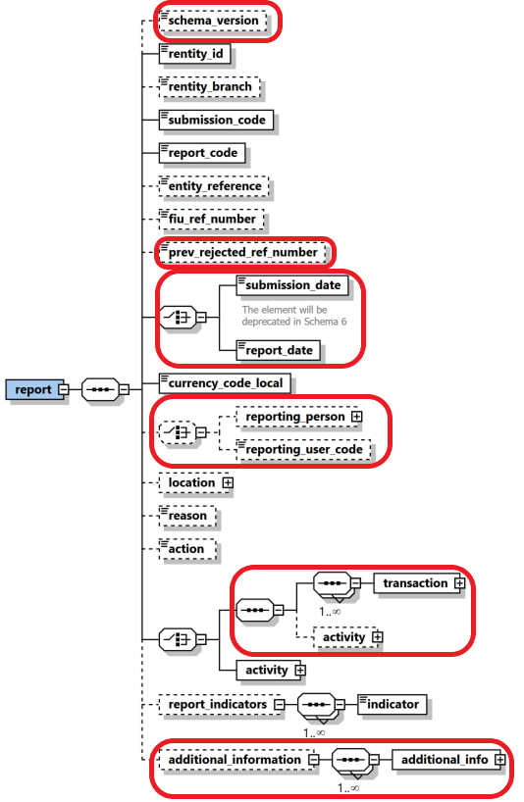

Figure 1: Overview node “report”

|  |  |  |  |  |  |  |  |  |  |  |  |  |  |  |  |  |  |
| --- | --- | --- | --- | --- | --- | --- | --- | --- | --- | --- | --- | --- | --- | --- | --- | --- | --- |
| **Name** | | | | **#Schema**  **#App** | | | | **Description** | | | | **Length** | | **Req.** | | **Example** | |
| schema_version | | | | Schema 5.0.1  App 5.1 | | | | Host the schema version which was used to generate the XML. | | | | 25 | | N | | 4.0.2  5.0.1 | |
| **rentity_id** | | | |  | | | | Reporting Entity number defined by FIU | | | | Integer  >= 1 | | **Y** | | 1237 | |
| rentity_branch | | | |  | | | | Branch of current reporting entity. | | | | 255 | | **N** | | Branch of Western Union who reported the transactions | |
| **submission_code** | | | |  | | | | Type of submission | | | | Enumeration | | **Y** | | See 5.1 Submission type | |
| **report_code** | | | |  | | | | Type of transaction (STR/CTR) | | | | Enumeration | | **Y** | | 5.8 Report Code | |
| entity_reference | | | |  | | | | Optional reference to the report, used by reporting entity | | | | 255 | | N | | STR Rep 392 | |
| fiu_ref_number | | | |  | | | | Optional ref. number to be used as communication channel between the FIU and the Reporting Entity when providing follow-up reports on the original report | | | | 255 | | N | | STR20220225 | |
| prev_rejected_ref_number | | | | Schema 5.0.1  App 5.1 | | | | Ref Number of a rejected report, to allow the FIU to better follow-up on rejected reports (entity_ref_number or Original Web Report Key if entity_ref_number is not available) | | | | 255 | | N | | 100-0-0 | |
| **submission_date** | | | | |  | | | Submission date and time | | | | Datetime | | **Y** | | 2022-02-25T11:55:00 | | |
| **report_date** | | | | | Schema 5.0.1  App 5.0 | | | This is a suggestion to phase out the current “submission_date” and replace it with better name. | | | | Datetime | | **Y** | | 2022-02-25T11:55:00 | | |
| **currency_code_**  **local** | | | |  | | | | Local Currency code | | | | Type “Currency-type” | | **Y** | | EUR | |
| reporting_person | | | | |  | | | Full details of the report’s reporting person | | | | Type “t_person_registration_in_report” | | N | |  | | |
| **reporting_user_**  **code** | | | | | **Schema 5.0.1**  **App 5.0** | | | **Currently, “reporting person” node can contain any name/details of a person, with no way to check if he/she is indeed a compliance officer in that RE. The “user_code” will be forced to have a valid user code of the RE or its delegation structure.** | | | | **50** | | **N** | | **User1** | | |
| **Location** | | | |  | | | | **Describes location of the reported report** | | | | **Type “t_address”** | | **N** | | **Mandatory: Same as “reporting pesrson”** | |
| **reason** | | | |  | | | | **Why the report was reported (especially or STRs)** | | | | **4000** | | **N** | | **Mandatory: Same as “reporting pesrson”** | |
| **action** | | | |  | | | | **Describes action related to the report** | | | | **4000** | | **N** | | **Mandatory: Same as “reporting pesrson”** | |
|  | | |  | | | |  | | |
|  | | | **transaction** | | | | | | **type**  **transaction** | **Y** | | | | **See 3.2 Node transaction** | | |
| **Activity (5.0)** | | | | | |  | **N** | | | | Optional Activity in Transactional Report | | |
|  | | | **Activity** | | | | | |  | **Y** | | | | See 3.3 Node activity | | |
| report_indicators | | | |  | | | | List of indicators for the current reports | | | | Type “indicator” | | 0..many | | See 3.11 Subnode report_indicators | |
| additional_information | | | | Schema 5.0.1  App 5.2 | | | | A new optional generic node for adding any unplanned extra information. See dedicated section. | | | | additional_information_type | | N | |  | |

Table 1: Details node “report”

## 3.1.2 Subnode report_indicators

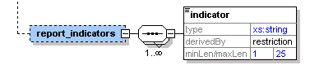

Figure 2: Overview subnode report_indicators

|  |  |  |  |  |
| --- | --- | --- | --- | --- |
| **Name** | **Description** | **Length** | **Req.** | **Example** |
| indicator | Some classification for the report | 25 | **Y**  When parent node “report_indicators” is provided | Crime,  Terror Funding, etc.  (FIU predefined list of codes) |

Table 2: Details subnode report_indicators

## 3.2.1 Node transaction

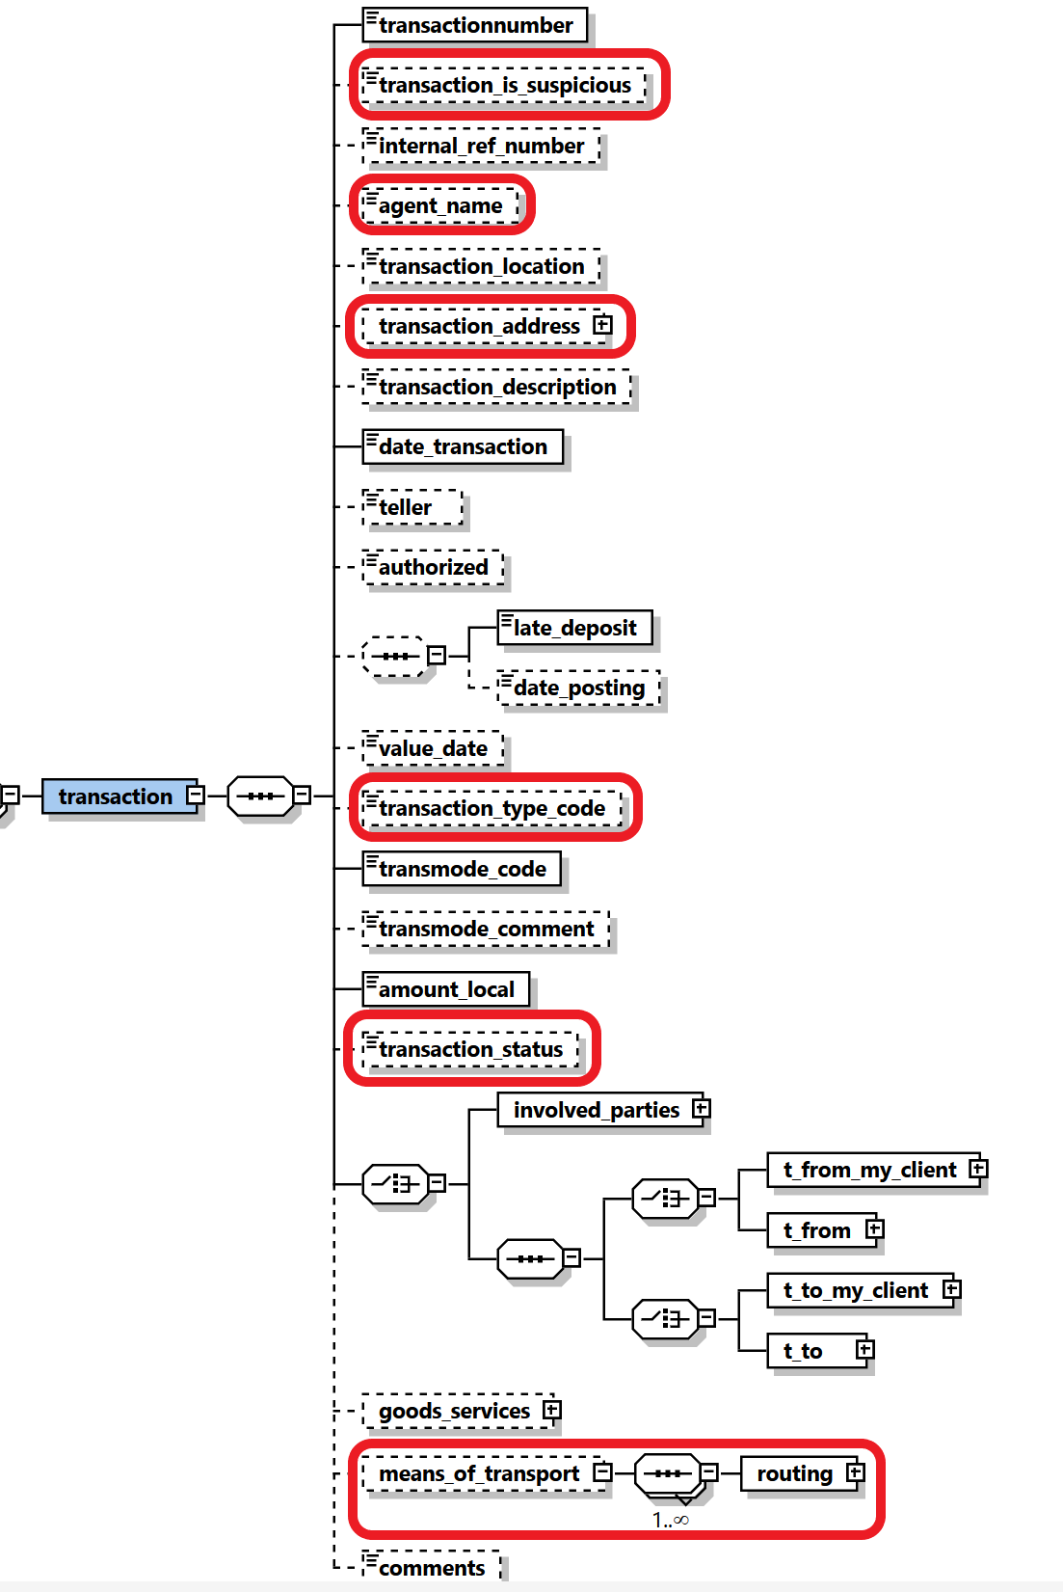

Figure 3: Overview node transaction

|  |  |  |  |  |  |  |  |  |
| --- | --- | --- | --- | --- | --- | --- | --- | --- |
| **Name** | | **#Schema**  **#App** | | **Description** | | **Length** | **Req.** | **Example** |
| **transactionnumber** | | Schema 5.0.1  App 5.1 | | Unique transaction number for bank transaction | | ~~50~~  **100** | **Y** | 20084711 |
| Transaction is suspicious | | Schema 5.0.1  App 5.1 | | indicate if the transaction is considered suspicious from the RE point of view. | | Boolean | **N** | True/False |
| Internal_ref_number | | Schema 5.0.1  App 5.1 | | Reporting Entity internal transaction reference number | | ~~50~~  100 | N | WU_BRNCH01_0001 |
| agent name | | Schema 5.0.1  App 5.1 | | Hosts the agent name in money transfer agencies case when the report is done by main service provider | | 255 | N | WU Agent |
| transaction_location | |  | | Branch/Location where the transaction took place | | 255 | N | Branch 001 |
| Transaction Address | | Schema 5.0.1  App 5.1 | | parallel to “**transaction_location**” element. The new node is a full address node. | | T_address | N | Full Address Node |
| transaction_ description | |  | | Free text field to describe the purpose of the transaction | | 4000 | N |  |
| **date_**  **transaction** | |  | | Date and time of the transaction | | DateTime | **Y** | 2006-03-25T11:55:00 |
| teller | |  | | Bank staff who conducted the transaction | | 50 | N | ID88933345 |
| authorized | |  | | Bank staff who authorized the transaction | | 20 | N | ID00033345 |
|  | | *late_deposit* and *date_posting* are both optional but when setting *date_posting,*  *late_deposit* becomes mandatory.  3 possible combinations  1. none of the nodes is set  2. only *late_deposit* is set  3. *late_deposit* AND *date_posting* are set | | | | | | |
| late_deposit | |  | | Late deposit indicator | | Boolean | N | True |
| date_  posting | |  | | Date of posting (if different from date of transaction) | | DateTime | N | 2006-03-24T19:55:00 |
| value_date | |  | | The actual date when the money will be credited (For example, Value date of a cheque) | | DateTime | N | 2006-03-27T00:00:00 |
| Transaction_Type | | Schema 5.0.1  App 5.1 | | answer the WHAT question while the current transaction_mode can be dedicated then to answer the HOW | | Enumeration | N | see 5.18 Transaction Type |
| **transmode_code** | |  | | How the transaction was conducted | | Enumeration | **Y** | See 5.6 Conduction Type |
| transmode_comment | |  | | Description if transmode_code is “O” (Other) | | 50 | N | - |
| **amount_**  **local** | |  | | The value of the transaction in local currency | | Decimal | **Y** |  |
| Transaction Status | | Schema 5.0.1  App 5.1 | | Describe if transaction was executed, on hold, blocked, ..etc. | | Enumeration | N | see 5.19 Transaction Status |
|  | | Transaction could be either a bi-party transaction with clear From and To sides, or a multi-party transaction with unlimited list of subjects (Persons, Accounts and Entities) where each has a role in the transaction rather than a clear from or to side. | | | | | | |
|  | | Bi-Party Transaction | | | | | | |
|  | | One of the nodes *t_from_my_client* or *t_from* should be provided. Both CANNOT be present together in a transaction, but one of them should be present. | | | | | |
|  | | **t_from_my_client** | | Specifies where the money came from. If the source is reporting bank’s client, then this node should be provided | Subnode | **Y**  (one of them) | See t_from_my_client | |
|  | | **t_from** | | Specifies where the money came from | Subnode | See 3.42 Node t_from | |
|  | | One of the nodes *t_to_my_client* or *t_to* should be provided. Both CANNOT be present together in a transaction, but one of them should be present. | | | | | |
|  | | **t_to_my_client** | | Specifies where the money went. If the destination is reporting bank’s client, then this node should be provided | Subnode | **Y**  (one of them) | See 3.51 Node t_to_my_client | |
|  | | **t_to** | | Specifies where the money went. | Subnode | See 3.52 Node t_to | |
|  | | Multi-Party Transaction | | | | | | |
|  | | This is a new node in schema 3.0. It covers transactions with multi-party involvement covering non-banking transactions. Car dealers for example can report such transactions where more than one subject bought/sold a car, while the car dealer is not reported as part of the transaction but only as the reporting entity. If the transaction is reported in this way, then at least one “Party” node should be reported. | | | | | |
|  | | **party** | | Describes the involved party details | Type “t_party” | **Y** | See 4.4 Type t_party | |
| Goods_  services | |  | | The goods/services linked to the transaction | | subnode | N | See 3.5 3.6 Subnode goods_services | |
| means_of_  transport | | Schema 5.0.1  App 5.2 | | capture customs related reports where subjects carry money cross borders as well as possible TBML reporting | | Subnode | **N** | 4.15 Means of Transportation Node | |
| Comments | |  | | Generic comments field | | 4000 | N |  | |

Table 3: Details node transaction

## 3.2.2 Transaction Additional Info Type

Introduced in schema 5.0.1, the type is used in goAML Application 5.1 to describe additional information in virtual currency and mobile money transactions regarding the used device, related IP address, blockchain block number and virtual address if the involved party is a Virtual Wallet.

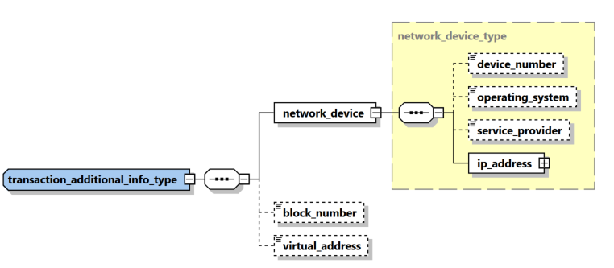

|  |  |  |  |  |  |
| --- | --- | --- | --- | --- | --- |
| **Name** | **#Schema**  **#App** | **Description** | **Length** | **Req.** | **Example** |
| device_number | Schema 5.0.1  App 5.1 | The number of device to send/receive the money in transaction context | 50 | N | 06501234567 |
| device_number | Schema 5.0.1  App 5.1 | The device operating system | Enumeration | N | iOS, Android, Windows, Mac OS, Linux… |
| service_provider | Schema 5.0.1  App 5.1 | The name of the service provider in case of mobile phone for example | 255 | N | Orange |
| **ip_address** | **Schema 5.0.1**  **App 5.1** | **Describes the details of the used “IP address”** | **Subnode** | **Y** | **See** 4.8.2 IP Address Type |
| Block_number | Schema 5.0.1  App 5.1 | blockchain block number | Decimal | N |  |
| virtual_address | Schema 5.0.1  App 5.1 | virtual address if the involved party is a Virtual Wallet | 255 | N |  |

## 3.3 Node Activity

Activity node was introduced first in schema 4.0 to represent an event where a list of subjects and goods are related directly to the report without the need of a transaction. In Schema 5, it was enhanced to include several new elements like set of “my client” PAE elements as well as country and “is suspected”. In addition, new schema supports since Application 5.0, a hybrid mode where set of one or many transactions can be followed by an activity node to allow reporting additional parties who are not involved directly in any of the reported transactions.

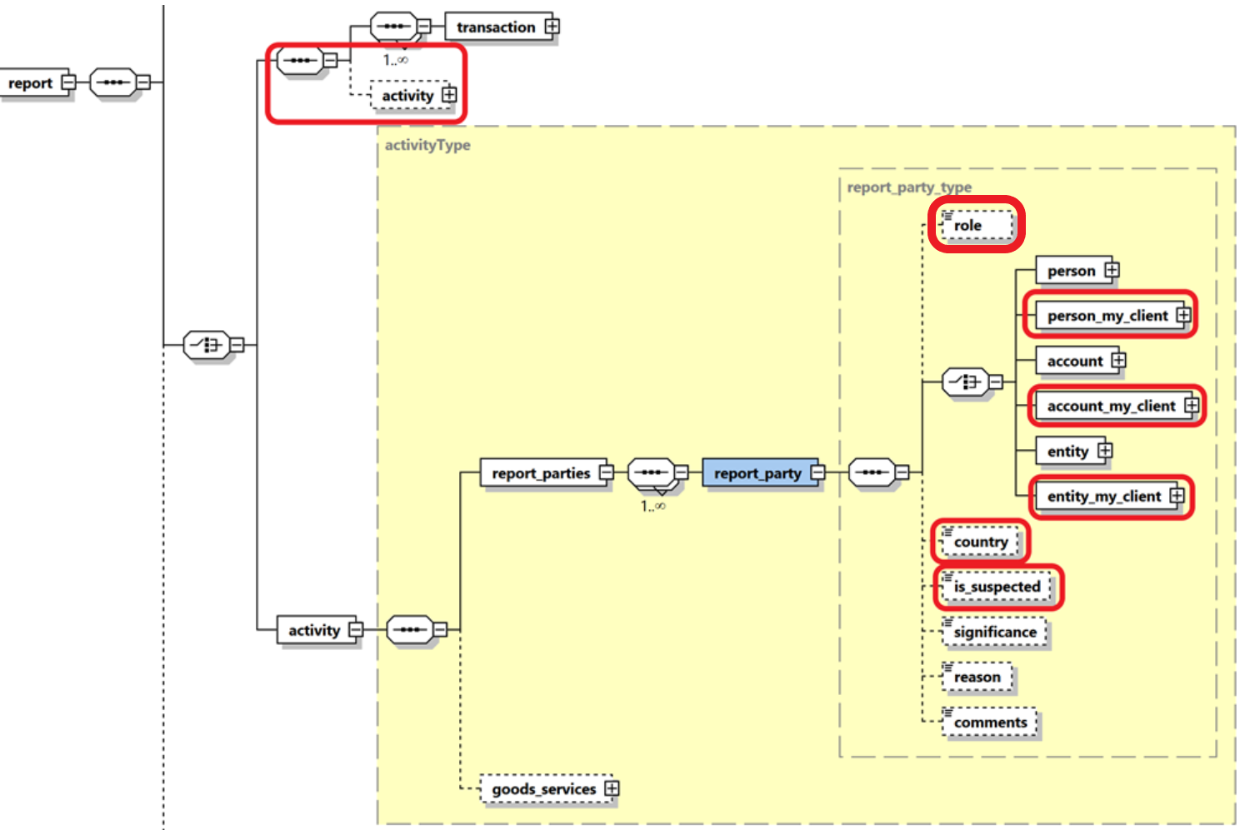

Figure 4: Overview node activity

|  |  |  |  |  |
| --- | --- | --- | --- | --- |
| **Name** | **Description** | **Length** | **Req.** | **Example** |
| **report_parties** | Represents a collection of involved subjects an involved subject with its details |  | **Y** |  |
| **report_party** | Represents a single involved subject with its details. At least one party should be included. | Type report_party_type | Y | See 4.9 Node report_party_type |
| goods_service | The standard goods_services node available in previous schemas | Type t_trans_item | N | - |

Table 4: Details node transaction

## 3.4.1 Node t_from_my_client

This node should be provided if the source side of the transaction is a client of the reporting entity.

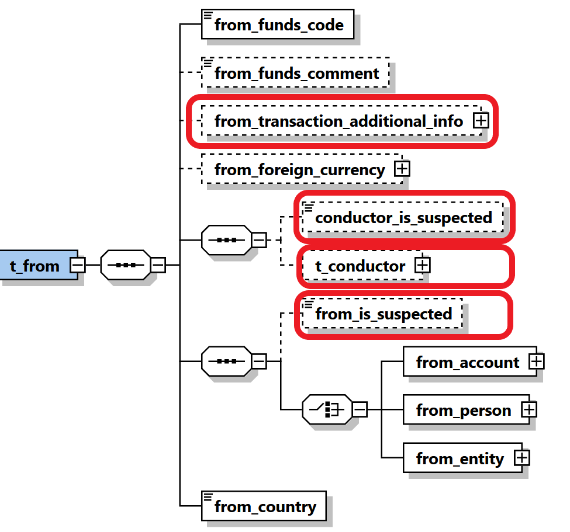

Figure 5: Overview node t_from_my_client

|  |  |  |  |  |  |
| --- | --- | --- | --- | --- | --- |
| **Name** | **#Schema**  **#App** | **Description** | **Length** | **Req.** | **Example** |
| **from_funds_**  **code** |  | Type of funds used in initiating transaction | Enumeration | **Y** | See 5.2 Funds type |
| from_funds_  comment |  | Description, if funds_code is “O” (Other). | 255 | N | - |
| From transaction Additional Information | Schema 5.0.1  App 5.1 | covers Virtual Currency and Mobile Money related transaction element | Subnode | N | See |
| from_foreign_  currency |  | If the transaction is conducted in foreign currency, then specify the foreign currency details. | type  t_foreign_currency | N | See 4.7 Type t_foreign_currency |
| conductor_is_  suspected | Schema 5.0.1  App 5.1 | Indicates if the conductor is a suspected party in this transaction | Boolean | N | True/False |
| t_conductor | Schema 5.0.1  App 5.1 | The person performing the transaction | type  t_conductor_my_client | N | See 4.31 Type t_person_my_client |
| **from_account** |  | Subnode that holds account information | type t_account_my_client | **Y**  (one of them only) | See 4.11 Type t_account_my_client |
| **from_person** |  | Subnode that holds “from person” information. | Type  t_person_my_client | See 4.31 Type t_person_my_client |
| **from_entity** |  | Subnode that holds “from entity” information. | Type t_entity_my_client | See 4.32 Type t_entity_my_client |
| **from_country** |  | Country where transaction was initiated. | Enumeration | **Y** | See 5.14 Country Codes |

Table 5: Details node t_from_my_client

## 3.4.2 Node t_from

This node should be provided if the source side of the transaction is NOT a client of the reporting entity.



Figure 6: Overview node t_from

|  |  |  |  |  |  |
| --- | --- | --- | --- | --- | --- |
| **Name** | **#Schema**  **#App** | **Description** | **Length** | **Req.** | **Example** |
| **from_funds_**  **code** |  | Type of funds used in initiating transaction | Enumeration | **Y** | See 5.2 Funds type |
| from_funds_  comment |  | Description, if funds_code is “O” (Other). | 255 | N | - |
| From transaction Additional Information | Schema 5.0.1  App 5.1 | covers Virtual Currency and Mobile Money related transaction element | Subnode | N | Transaction Additional Info Type |
| from_foreign_  currency |  | If the transaction is conducted in foreign currency, then specify the foreign currency details. | type  t_foreign_currency | N | See 4.7 Type t_foreign_currency |
| conductor_is_  suspected | Schema 5.0.1  App 5.1 | Indicates if the conductor is a suspected party in this transaction | Boolean | N | True/False |
| t_conductor | Schema 5.0.1  App 5.1 | The person performing the transaction | type  t_conductor | N | See 4.31 Type t_person_my_client |
| From_is_  suspected | Schema 5.0.1  App 5.1 | Indicates if the from party is a suspected party in this transaction | Boolean | N | True/False |
| **from_account** |  | Subnode that holds account information | type t_account | **Y**  (one of them only) | See 4.11 Type t_account_my_client |
| **from_person** |  | Subnode that holds “from person” information. | Type  t_person | See 4.31 Type t_person_my_client |
| **from_entity** |  | Subnode that holds “from entity” information. | Type t_entity | See 4.32 Type t_entity_my_client |
| **from_country** |  | Country where transaction was initiated. | Enumeration | **Y** | See 5.14 Country Codes |

Table 6: Details node t_from

## 3.5.1 Node t_to_my_client

This node should be provided if the destination side of the transaction is a client of the reporting bank.

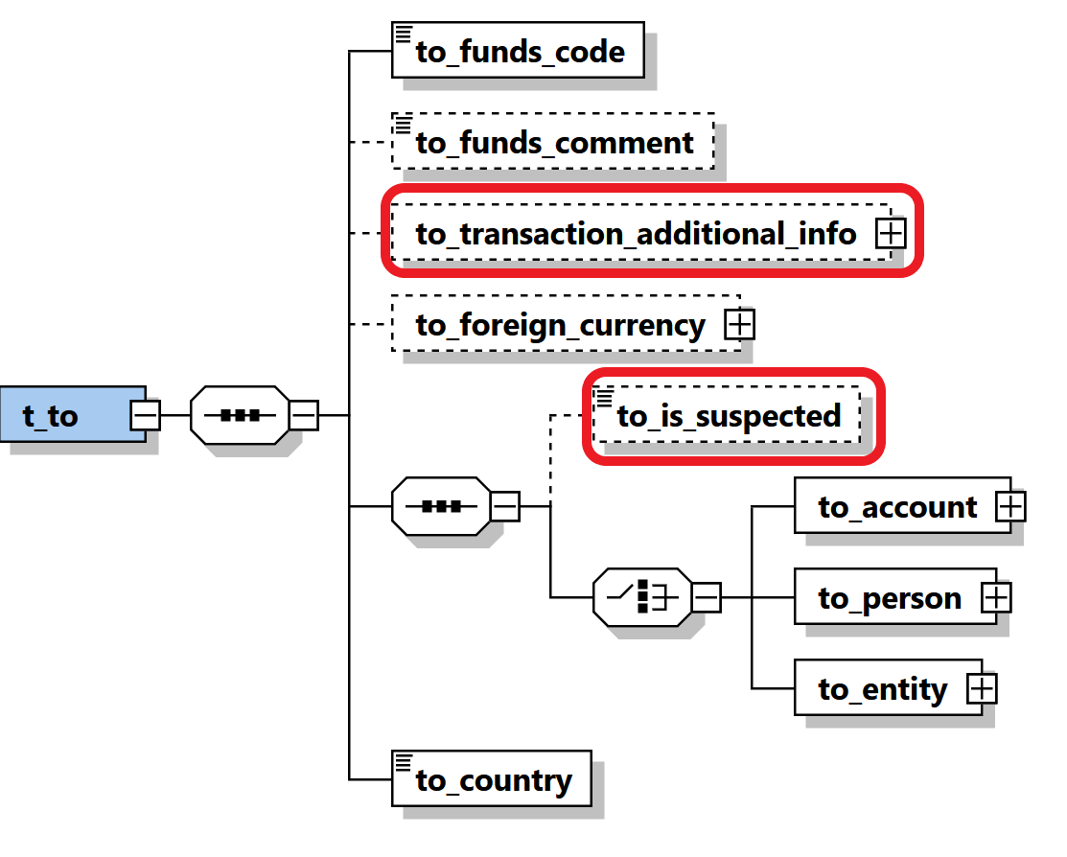

Figure 7: Overview node t_to_my_client

|  |  |  |  |  |  |
| --- | --- | --- | --- | --- | --- |
| **Name** | **#Schema**  **#App** | **Description** | **Length** | **Req.** | **Example** |
| **to_funds_code** |  | Disposition of funds | Enumeration | **Y** | See 5.2 Funds type |
| to_funds_comment |  | Description, if funds_code is “O” (Other) or policy number. | 255 | N | - |
| to_transaction Additional Information | Schema 5.0.1  App 5.1 | covers Virtual Currency and Mobile Money related transaction element | Subnode | N | Transaction Additional Info Type |
| to_foreign_  currency |  | If the transaction is conducted in foreign currency, then specify the foreign currency details. | type  t_foreign_currency | N | See 4.7 Type t_foreign_currency |
| to_is_  suspected | Schema 5.0.1  App 5.1 | Indicates if the “to” party is a suspected party in this transaction | Boolean | N | True/False |
| **to_account** |  | Subnode that holds account information | type t_account_my_client | **Y**  (one of them) | See *4.11 Type* t_account_my_client |
| **to_person** |  | Subnode that holds person information | type t_person_my_client | See 4.31 Type t_person_my_client |
| **to_entity** |  | Subnode that holds “to entity” information. | Type t_entity_my_client | See 4.32 Type t_entity_my_client |
| **to_country** |  | Target country of the transaction | Enumeration | **Y** | See 5.14 Country Codes |

Table 7: Details node t_to_my_client

## 3.5.2 Node t_to

Information about the transaction disposition(s) - i.e. where the money went.

*t_to* can either point to a person or to an account.



Figure 8: Overview node t_to

|  |  |  |  |  |  |
| --- | --- | --- | --- | --- | --- |
| **Name** | **#Schema**  **#App** | **Description** | **Length** | **Req.** | **Example** |
| **to_funds_code** |  | Disposition of funds | Enumeration | **Y** | See 5.2 Funds type |
| to_funds_comment |  | Description, if funds_code is “O” (Other) or policy number. | 255 | N | - |
| to_transaction Additional Information | Schema 5.0.1  App 5.1 | covers Virtual Currency and Mobile Money related transaction element | Subnode | N | Transaction Additional Info Type |
| to_foreign_  currency |  | If the transaction is conducted in foreign currency, then specify the foreign currency details. | type  t_foreign_currency | N | See 4.7 Type t_foreign_currency |
| to_is_  suspected | Schema 5.0.1  App 5.1 | Indicates if the “to” party is a suspected party in this transaction | Boolean | N | True/False |
| **to_account** |  | Subnode that holds account information | type t_account | **Y**  (one of them) | See *4.11* t_account_my_client |
| **to_person** |  | Subnode that holds person information | type t_person | See 4.31 t_person_my_client |
| **to_entity** |  | Subnode that holds “to entity” information. | Type t_entity | See 4.32 t_entity_my_client |
| **to_country** |  | Target country of the transaction | Enumeration | **Y** | See 5.14 Country Codes |

Table 8: Details node t_to

## 3.6.1 Node t_party

This type is used to represent Multi-Party transaction parties

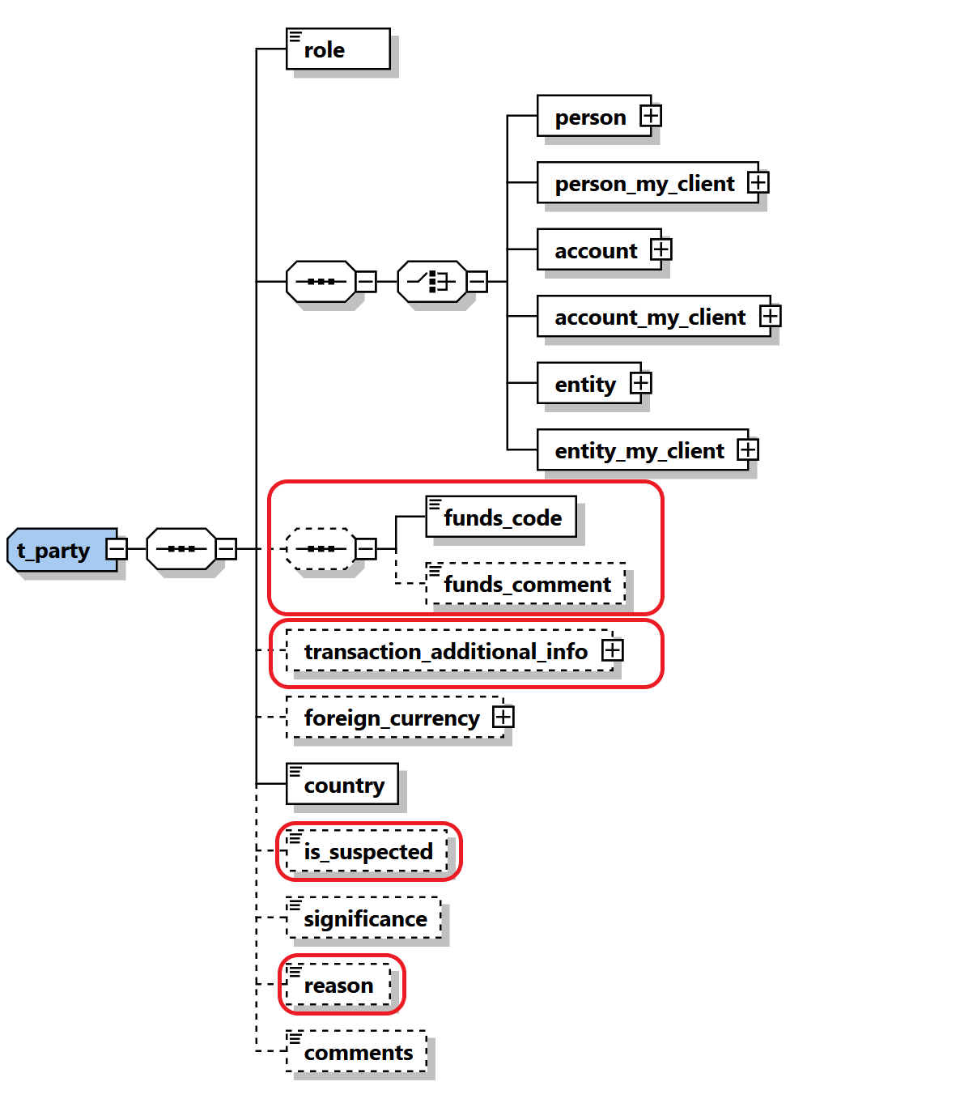

Figure 9: Overview type t_party

|  |  |  |  |  |  |  |
| --- | --- | --- | --- | --- | --- | --- |
| **Name** | | **#Schema**  **#App** | **Description** | **Length** | **Req.** | **Example** |
| **role** | |  | Subject role in the transaction | Enumeration | **Y** | Buyer, Seller,.. |
|  | Subject: One occurrence of the supported subject types must be included. | | | | | |
| Person | |  | Involved Person | Type “t_person” | **Y** | See 4.32 Type t_person |
| Person_my_client | |  | Involved Person | Type “t_person_  my_client” | **Y** | See 4.31 Type t_person_my_client |
| account | |  | Involved Account | Type “t_account” | **Y** | See *4.12 Type* t_account |
| account_  my_client | |  | Involved Account | Type “t_ account_my_client” | **Y** | See *4.11 Type* t_account_my_client |
| entity | |  | Involved Entity | Type “t_ entity” | **Y** | See 4.22 Type t_entity |
| entity_my_client | |  | Involved Entity | Type “t_ entity_my_client” | **Y** |  |
| funds_code | |  | Type of funds used in initiating transaction | Enumeration | N | See 5.2 Funds type |
| funds_comment | |  | Description, if funds_code is “O” (Other). | 255 | N | - |
| transaction Additional Information | | Schema 5.0.1  App 5.1 | covers Virtual Currency and Mobile Money related transaction element | Subnode | N | Transaction Additional Info Type |
| foreign_currency | |  | If the transaction is conducted in foreign currency, then specify the foreign currency details. | type  t_foreign_currency | N | See 4.7 Type t_foreign_currency |
| **country** | |  | Country of the transaction | Enumeration | **Y** | See 5.14 Country Codes |
| is_  suspected | | Schema 5.0.1  App 5.1 | Indicates if the “to” party is a suspected party in this transaction | Boolean | N | True/False |
| significance | |  | The significance of the subject in the transaction | Integer | N | 0-10 |
| Reason | | Schema 5.0.1  App 5.1 | Describe the reason why the party is included | 8000 | N |  |
| comments | |  | Generic comments | 8000 | N |  |

Table 9: Details type t_party

## 3.7 Subnode goods_services

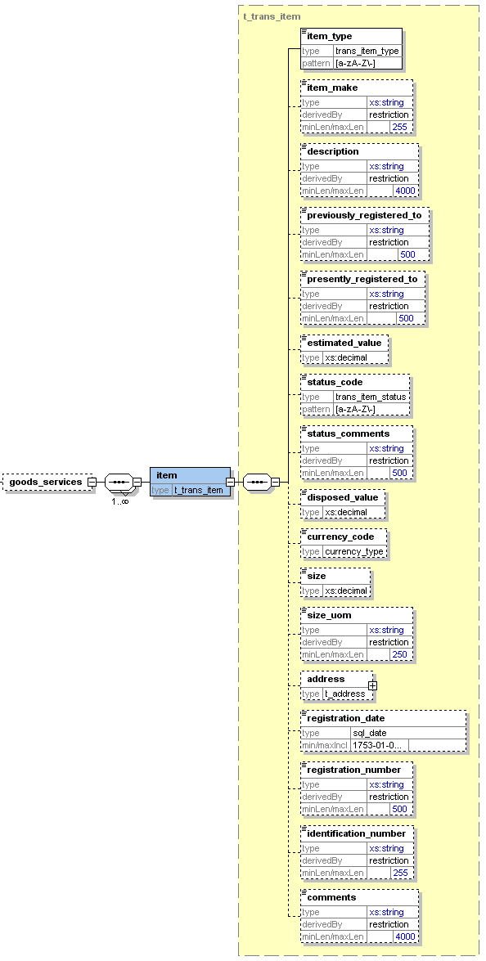

Figure 9: Overview subnode goods_services

|  |  |  |  |  |
| --- | --- | --- | --- | --- |
| **Name** | **Description** | **Length** | **Req.** | **Example** |
| **Item_type** | Lookup code describes the item type | Type “trans_item_type” | **Y** | C = Car  L = Land |
| Item_make | Item Maker | 255 | N | In case of Car for example, BMW |
| description | Text | 8000 | N | Apartment building |
| previously_registered_to | Name of previous owner | 500 | N | John Smith |
| presently_registered_to | Name of current owner | 500 | N | Jane Smith |
| estimated_value | Estimated value of the property – Used Currency is the one specified in node *from_currency* | Decimal | N | 250000.00 |
| status_code | Status code | Enumeration | N | See 5.7 Transaction Item Status |
| status_comments | Status Comments | 500 | N |  |
| disposed_value | effective value for property transfer – Used Currency is the one specified in node *from_currency* | Decimal | N | 500000.00 |
| Currency_code | used to report service conducted in foreign currency | Enumeration | **N** | See 5.13 Currencies |
| size | Size of the property – in unit specified in node *size_uom* | Decimal | N | 150 |
| size_uom | Unit of measurement | 250 | N | Square meters |
| address | Address of the property | type t_address | N | *4.5 Type* t_address |
| registration_date | Official registration date | DateTime | N | 2001-12-17T09:30:47 |
| registration_number | Official registration number | 500 | N | Car VIN Number |
| Identification_number | Any number that can identify the item | 255 | N | Car Plate Number |
| Comments | Additional comments | 8000 | N |  |

Table 9: Details subnode goods_services

# Description Of Common Types Used in the Schema

## *4.1.1 Type* t_account_my_client/t_account

The structure of these 2 types is exactly the same*,* it is introduced just to allow FIUs to add more restrictions when the account is the hosted in the reporting entity in comparison to an account of another RE. i.e., some nodes which are not mandatory in *t_account* can be set mandatory in *t_account_my_client.*

These restrictions are defined by the local FIU. The logic here is that whenever the involved account or person is the client of the reporting entity, more details may be demanded, and the reporting entity must have the information as part of the adherence to the “Know Your Customer” (KYC) philosophy of compliance.

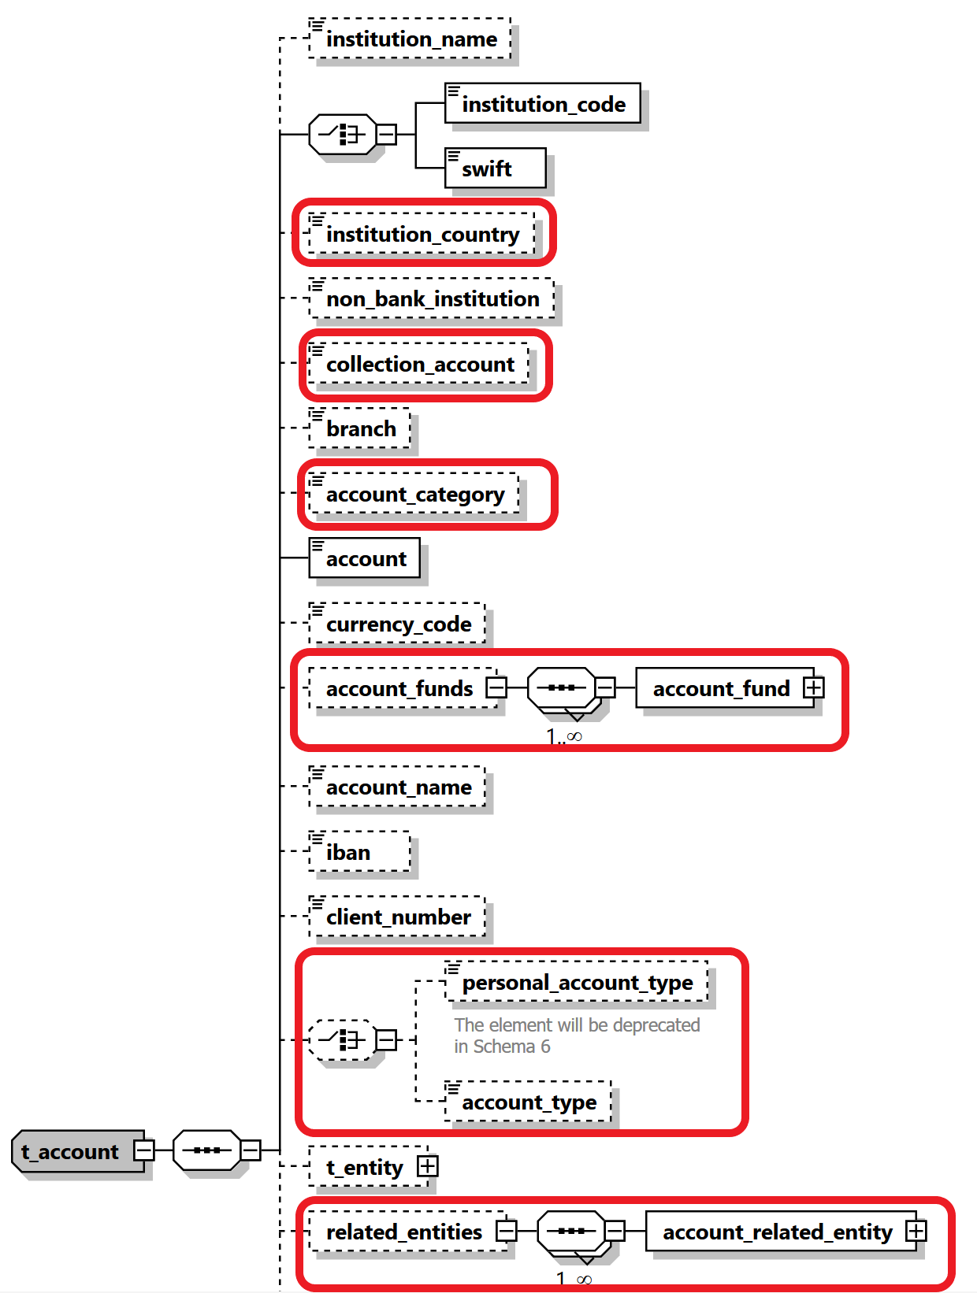

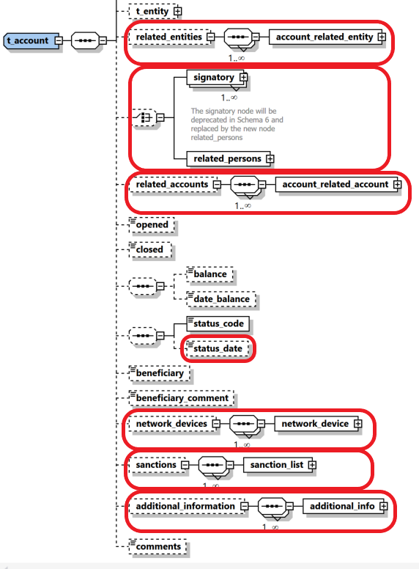

Figure 10: Overview type t_account_my_client

|  |  |  |  |  |  |  |  |  |  |  |  |  |  |
| --- | --- | --- | --- | --- | --- | --- | --- | --- | --- | --- | --- | --- | --- |
| **Name** | | **#Schema**  **#App** | | | **Description** | | **Length** | | | **Req.** | | **Example** | |
| Instituation_name | |  | | | The name of the Bank | | 255 | | | N | | Bank of … | |
| **institution_code** | |  | | | Institution code | | | 50 | | **Y**  (one of them) | | - | |
| **swift** | |  | | | SWIFT code according to ISO 9362 | | | 11 | | ATTBVI | |
| Institution Country | | Schema 5.0.1  App 5.1 | | | The country of the reported bank especially relevant for foreign banks | | Enumeration | | | N | | UN | |
| Non_banking_  institution | |  | | | A flag to cover cases where the account belongs to non-banking institution | | Boolean | | | N | | Investment company | |
| Collection Account | | Schema 5.0.1  App 5.1 | | | Indicate that the reported account is a collection account and is not owned really by the reported subject | | Boolean | | | N | | True/False | |
| Branch | |  | | | Branch code or name | | 255 | | | N | | ABX12 | |
| Account Category | | Schema 5.0.1  App 5.1 | | | Allow different presentations of the Account element, e.g., Account, IBAN, Payment Card, Email, Mobile number as well as **Virtual Addresses** and **Wallets** | | Enumeration | | | N | | IBAN | |
| **Account** | | Schema 5.0.1  App 5.1 | | | Account number  Enlarged and can host now as well IBAN, Wallet, Virtual Address, etc. | | ~~50~~  255 | | | **Y** | | 31032027088 | |
| currency_code | |  | | | Currency the account is kept in | | Enumeration | | | N | | See 5.13 Currencies | |
| Account Funds | | Schema 5.0.1  App 5.1 | | | allow capturing different funds for the same account. This will be implemented first to handle **Wallet** funds but can be extended later to host different currencies in one main account for example. | | SubNode | | | N | | See 4.1.6 Type Account Funds | |
| account_name | |  | | | This is a free text field used to “Label” the account, for example a saving book account with anonymous owner, or an Entity account dedicated to Invoices, etc. | | 255 | | | N | | Private savings account | |
| iban | |  | | | IBAN | | 34 | | | N | | LT601010012345678901 | |
| client_number | |  | | | Client number | | 30 | | | N | | 31032027088 | |
|  | |  | | |  | |  | | |  | |  | |
| personal_account_type | | |  | | Account Type  Will be deprecated in the next schema | | Enumeration | | | N | | See 5.3 Account type | |
| account_type | | | Schema 5.0.1  App 5.1 | | Same as Account Type, jus better name since the type is the same for private of business accounts | | Enumeration | | | N | | See 5.3 Account type | |
| t_entity | |  | | | Business entity owning the account | | type  t_entity | | | N | | See 4.22 Type t_entity | |
| related_entities | | Schema 5.0.1  App 5.1 | | | A new one to many relations to allow Reporting Entities to report several entities having some kind of relation to an account in addition to the current Entity owning the account node. | | Subnode | | | N | | See 4.1.5 Type Account Related Entity | |
| signatory | | |  | | Person(s) with access to the account. | | Subnode (can repeated to specify multiple signatories). Note that the node t_person is of type t_person_my_client | | | N | | See 4.1.2 Type Signatory | |
| related_persons | | | Schema 5.0.1  App 5.1 | | New Choice was introduced to allow deprecating the current root level Signatory node and replace it with cover node related_persons with multiple occurrences of single related_person element. | | Subnode | | | N | | 4.1.3 Type Account Related Persons | |
| related_accounts | | Schema 5.0.1  App 5.1 | | | A new one to many relations to allow Reporting Entities to report several accounts as related to the main reported account | | SubNode | | | N | | 4.1.4 Type Account Related Accounts | |
| opened | |  | | | Date account opened | | DateTime | | | N | | 2003-01-25T00:00:00 | |
| closed | |  | | | Date account closed | | DateTime | | | N | | 2006-03-25T00:00:00 | |
| balance | |  | | | The account balance after the transaction was conducted. | | Decimal | | | N | | 5000.50 | |
| date_balance | |  | | | A date to specify the date of the reported balance. Application will show balance history | | DateTime | | | N | |  | |
| status_code | |  | | | Account status when transaction was initiated | | Enumeration | | | N | | 5.4 Account status type | |
| Status_date | | Schema 5.0.1  App 5.1 | | | A date to specify the date of the account status. Application will show balance history | | DateTime | | | N | |  | |
| network_devices | | Schema 5.0.1  App 5.2 | | | supports multi occurrence of “network device”. | | Subnode | | | N | | 4.9.1 Network Device Type | |
| beneficiary | |  | | | Ultimatebeneficiary of the account | | 50 | | | N | | Ella Machera | |
| beneficiary_  comment | |  | | | Any special remark on the beneficiary | | 255 | | | N | |  | |
| sanctions | | Schema 5.0.1  App 5.2 | | | supports multi occurrence of “sanction list”. | | Subnode | | | N | | 4.13 Sanctions Node | |
| additional_  information | | Schema 5.0.1  App 5.2 | | | A new optional generic node for adding any unplanned extra information. See dedicated section. | | SubNode | | | N | | 4.12 Additional Information | |
| comments | |  | | | Generic comments elements | | 8000 | | | N | |  | |

Table 10: Details type t_account_my_client

## *4.1.2 Type* Signatory

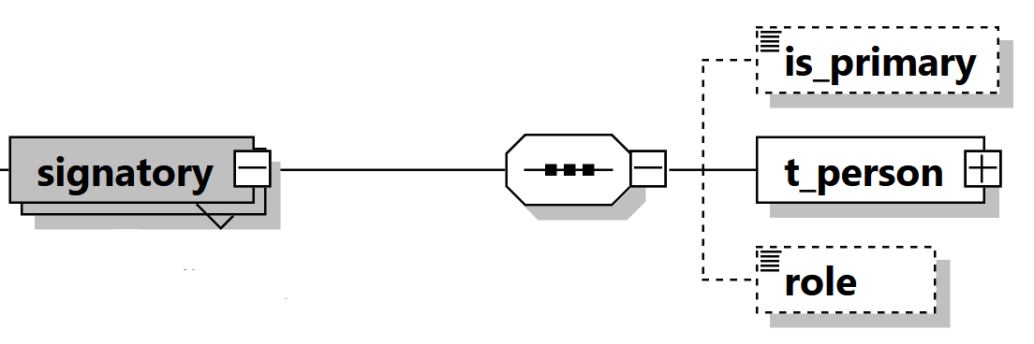

|  |  |  |  |  |  |
| --- | --- | --- | --- | --- | --- |
| is_primary |  | Identifies the primary account holder. Only one signatory may be marked as *is_primary.* Has to be ‘true’ when node is set. | fixed = 1 | N |  |
| t_person |  | Subnode holding detailed information about the signatory. Mandatory for signatories in the XML report. | type  t_person_my_client | Y | See 4.31 Type t_persony |
| role |  | Subnode holding enumeration about the role of current signatory with the account. report. | type  “account_person_role_type” | N |  |

## *4.1.3 Type* Account Related Persons

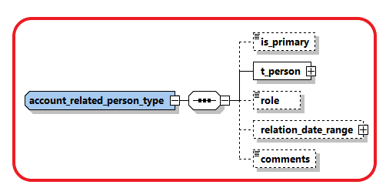

|  |  |  |  |  |  |
| --- | --- | --- | --- | --- | --- |
| is_primary |  | Identifies the primary account holder. Only one signatory may be marked as *is_primary.* Has to be ‘true’ when node is set. | fixed = 1 | N |  |
| t_person |  | Subnode holding detailed information about the signatory. Mandatory for signatories in the XML report. | type  t_person | Y | See 4.31 Type t_person |
| role |  | Subnode holding enumeration about the role of current signatory with the account. report. | type  “account_person_role_type” | N |  |
| relation_date_range | Schema 5.0.1  App 5.1 | Subnode to describe the date range relation | Type “relation_data_range_type” | N |  |
| comments |  | Generic Comments | 8000 | N |  |

## *4.1.4 Type* Account Related Accounts

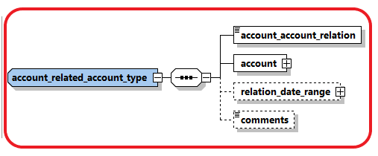

|  |  |  |  |  |  |
| --- | --- | --- | --- | --- | --- |
| account_account_  relation | Schema 5.0.1  App 5.1 | Describe the relation between the related two accounts | enumeration | Y |  |
| account |  | Subnode holding detailed information about the Related Account. | type  t_account | Y | See 4.31 Type t_account |
| relation_date_range |  | Subnode to describe the date range relation | Type “relation_data_range_type” | N |  |
| comments |  | Gneric Comments | 8000 | N |  |

## *4.1.5 Type* Account Related Entity

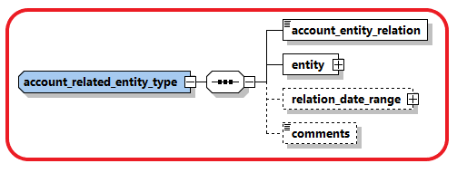

|  |  |  |  |  |  |
| --- | --- | --- | --- | --- | --- |
| account_entity_  relation | Schema 5.0.1  App 5.1 | Describe the relation between the account and related entity | enumeration | Y |  |
| entity |  | Subnode holding detailed information about the related entity. | type  t_entity | Y | See 4.31 Type t_entity |
| relation_date_range |  | Subnode to describe the date range relation | Type “relation_data_range_type” | N |  |
| comments |  | Generic Comments | 8000 | N |  |

## *4.1.6 Type* Account Funds

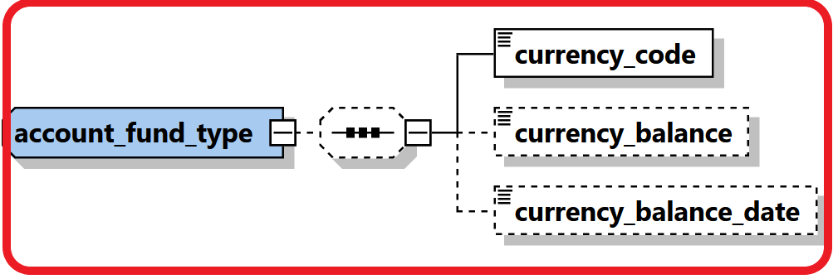

|  |  |  |  |  |  |
| --- | --- | --- | --- | --- | --- |
| currency_code | Schema 5.0.1  App 5.1 | Describe the currency of the funds | enumeration | Y |  |
| currency_balance | Schema 5.0.1  App 5.1 | Balance of the funds. | Decimal | N |  |
| currency_balance_date | Schema 5.0.1  App 5.1 | Balance of the funds. | DateTime” | N |  |

## 4.2.1 Type t_entity_my_client/t_entity

The structure of these 2 types is exactly the same*,* it is introduced just to allow FIUs to add more restrictions when the entity is the hosted in the reporting entity in comparison to an entity which is the customer of another RE. i.e., some nodes which are not mandatory in *t_entity* can be set mandatory in *t_entity_my_client.*

These restrictions are defined by the local FIU.

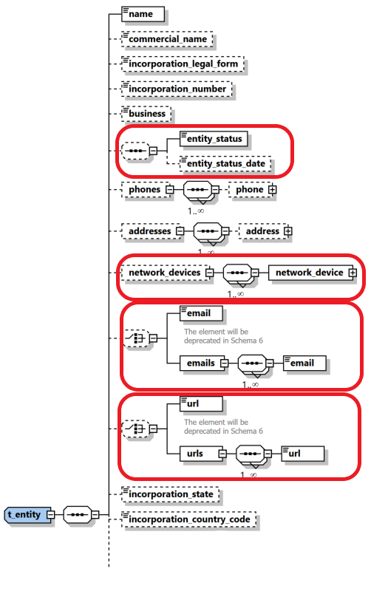

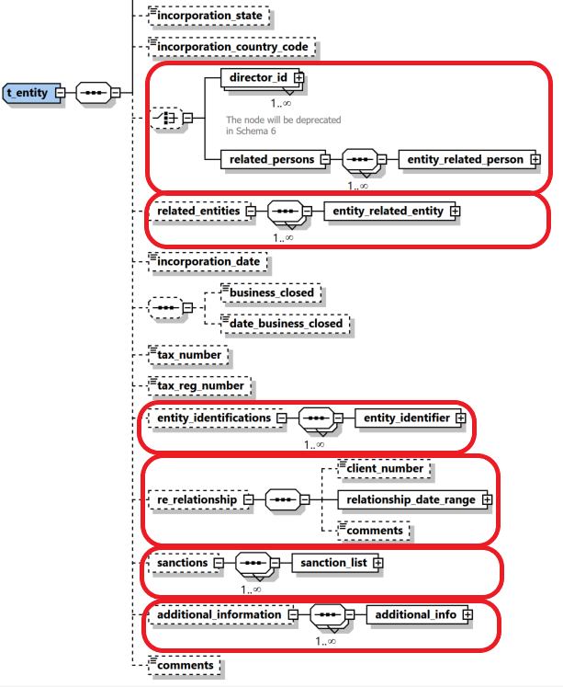

Figure 5: Overview type t_entity

|  |  |  |  |  |  |  |  |  |  |  |  |  |  |
| --- | --- | --- | --- | --- | --- | --- | --- | --- | --- | --- | --- | --- | --- |
| **Name** | | **#Schema**  **#App** | | | **Description** | | **Length** | | **Req.** | | **Example** | | |
| **Name** | |  | | | Name of Entity | | 255 | | **Y** | | DoeComp | | |
| Commercial_name | |  | | | The “traded as” name of the entity | | 255 | | N | |  | | |
| Incorporation_legal_  form | |  | | | The legal form of the entity | | Type “legal_form_type” | | N | | See 5.11  Ltd., GmbH, | | |
| incorporation_  number | |  | | | The registration number of the entity/"company" in the relevant authority (e.g. Chamber of Commerce) | | 50 | | N | | - | | |
| Business | |  | | | Business area of the entity | | 255 | | N | | Free text describing business e.g., IT Services, Imports, Export etc. | | |
| Entity Status | | Schema 5.0.1  App 5.2 | | | describing the status of the entity | | Enumeration | | N | | ACTVE | | |
| Entity Status Date | | Schema 5.0.1  App 5.2 | | | describing the date of entity status | | DateTime | | N | |  | | |
| Phones | |  | | | A Holder node for a 1..many Phones | |  | | N | |  | | |
| **Phone** | |  | | | One occurrence of phone node | | Type “t_phone” | | **Y**  When “Phones” is provided | | See *4.6 Type* t_phone | | |
| Addresses | |  | | | A Holder node for a 1..many Addresses | |  | | N | |  | | |
| **Address** | |  | | | One occurrence of address node | | Type “t_address” | | **Y**  When “Addresses” is provided | | *4.5 Type* t_address | | |
| network_devices | | Schema 5.0.1  App 5.2 | | | supports multi occurrence of “network device”. | | Subnode | | N | | See 4.8.1 Network Device Type | | |
| Email | | |  | | Email address | | email_address (255) | | | N | | [test@mail.com](mailto:test@mail.com) | |
| emails | | | Schema 5.0.1  App 5.2 | | supports several emails for the reported entity in comparison with currently one email | | email_address (255) | | | N | |  | |
|  | | |  | |  | |  | | |  | |  | |
| url | | |  | | Entity web address | | 255 | | | N | | [www.entity.com](http://www.entity.com) | |
| urls | | |  | | supports several urls for the reported entity in comparison with currently one url | | 255 | | | N | | [www.entity.com](http://www.entity.com) | |
| Incorporation_state | |  | | | Name of the State | | 255 | | N | | - | | |
| incorporation_  country_code | |  | | | Country | | Enumeration | | N | | See 5.14 Country Codes | | |
| director_id | |  | | | Individuals authorized | | type t_person  (Subnode can be repeated for multiple persons) | | N | | See 4.31 Type t_person/t_person_my_client | | |
| related_persons | | Schema 5.0.1  App 5.2 | | | Parent node for multiple related_persons. Director_id will be deprecated in future schemas. | | subnode | | N | | See 4.2.2 Type Entity Related Persons | | |
| related_entities | | Schema 5.0.1  App 5.0 | | | Supports creating relations between different entities | | Subnode | | N | | See 4.2.3 Type Entity Related Entities | | |
| incorporation_date | |  | | | Incorporation registration date | | Date | | N | |  | | |
| business_closed | |  | | | Boolean to indicate if the company is closed down | | Boolean | | N | |  | | |
| date_business_  closed | |  | | | If entity is closed then specify close date if any. | | Date | | N | |  | | |
| tax_numebr | |  | | | The entity tax number | | 100 | | N | |  | | |
| tax_registeration_  number | |  | | | Registration number of the entity by the Tax auth. | | 100 | | N | |  | | |
| entity_identifications | | Schema 5.0.1  App 5.2 | | | Similar to Person Identifications, a repeated sub node for Entity identification numbers was introduced. | | Subnode | | N | | See 4.2.4 Type Entity Identifications | | |
| business relationship | | Schema 5.0.1  App 5.2 | | | host the starting and dates of the relationship between the **Reporting Entity** and the Entity | | Subnode | | N | | 4.12 Business Relationship | | |
| sanctions | | Schema 5.0.1  App 5.2 | | | supports multi occurrence of “sanction list”. | | Subnode | | N | | 4.13 Sanctions Node | | |
| additional_  information | | Schema 5.0.1  App 5.2 | | | A new optional generic node for adding any unplanned extra information. See dedicated section. | | SubNode | | N | | 4.12 Additional Information | | |
| Comments | |  | | | Generic comments field | | 8000 | | N | |  | | |

Table 5: Details type t_entity

## *4.2.2 Type* Entity Related Persons

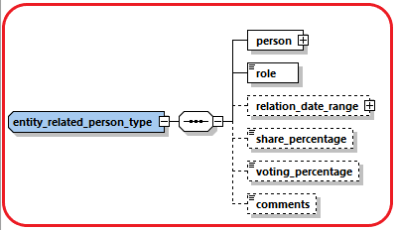

|  |  |  |  |  |  |
| --- | --- | --- | --- | --- | --- |
| person |  | Subnode holding detailed information about the signatory. | type  t_person | Y | See 4.31 Type t_person |
| role |  | Subnode holding enumeration about the role of current signatory in the entity | type  “entity_person_role_type” | N | 5.16 Entity Person Role Type |
| relation_date_range | Schema 5.0.1  App 5.2 | Subnode to describe the date range relation | Type “relation_data_range_type” | N |  |
| share_percentage | Schema 5.0.1  App 5.2 | Value of shares owned by the related person – if any. | Decimal | N |  |
| Voting_percentage | Schema 5.0.1  App 5.2 | Value of voting rights owned by the related person – if any. | Decimal | N |  |
| comments |  | Generic Comments | 8000 | N |  |

## *4.2.3 Type* Entity Related Entities

Introduced in goAML Release 5.0 to allow reporting relations between different entities. The relation type should describe always how the reported entity is related to the other related entities.

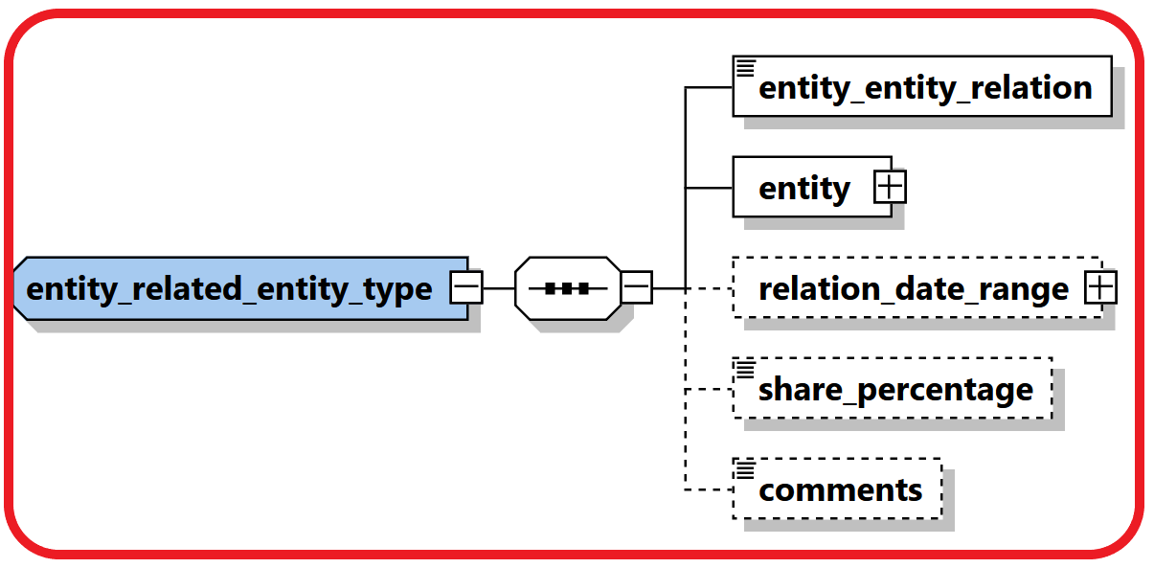

|  |  |  |  |  |  |
| --- | --- | --- | --- | --- | --- |
| entity_entity_  relation | Schema 5.0.1  App 5.0 | Describe the relation between the two and related entities. | enumeration | Y | 5.17 Entity-Entity Relation Type |
| entity |  | Subnode holding detailed information about the related entity. | type  t_entity | Y | See 4.31 Type t_entity |
| relation_date_range | Schema 5.0.1  App 5.0 | Subnode to describe the date range relation | Type “relation_data_range_type” | N |  |
| share_percentage | Schema 5.0.1  App 5.0 | Describes the percentage of shares held between the two entities, relation type determines who owns the shares. | Decimal | N |  |
| comments |  | Generic Comments | 8000 | N |  |

## *4.2.4* Entity Identifications

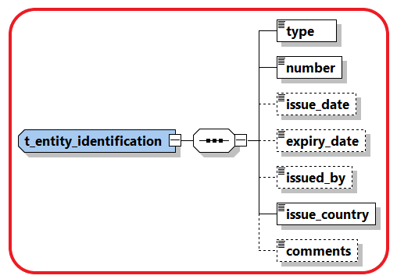

|  |  |  |  |  |
| --- | --- | --- | --- | --- |
| **Name** | **Description** | **Length** | **Req.** | **Example** |
| **type** | **Document type** | **Enumeration** | **Y** | **5.5 Identifier type** |
| **number** | **ID of the identification document** | **255** | **Y** | **AT08154711** |
| issue_date | Identification document issue date | DateTime | N | 2001-12-17T09:30:47 |
| expiry_date | Identification document expiry date | DateTime | N | 2012-01-01T00:00:00 |
| issued_by | Name of Authority issued the document | 255 | N | Interior Ministry |
| **issue_country** | **Country where the document was issued** | **Enumeration** | **Y** | **See 5.14 Country Codes** |
| comments | Generic comments field | 8000 | N |  |

## 4.3.1 Type t_person_my_client/t_person

The structure of these 2 types is exactly the same*,* it is introduced just to allow FIUs to add more restrictions when the person is a customer of the reporting entity in comparison to a person which is the customer of another RE. i.e., some nodes which are not mandatory in *t_person* can be set mandatory in *t_person_my_client.*

These restrictions are defined by the local FIU.

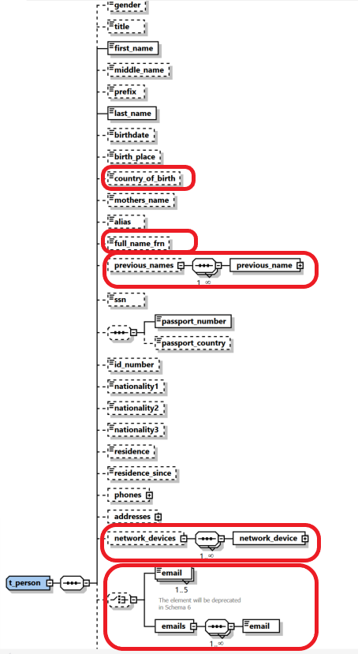

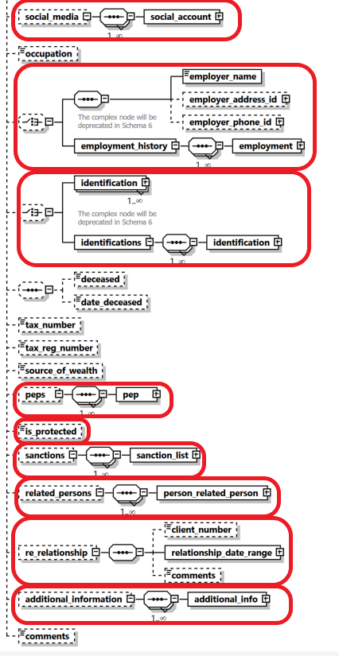

Figure 7: Overview type t_person

|  |  |  |  |  |  |  |  |  |  |  |  |  |  |  |  |  |  |  |  |  |  |  |  |  |  |  |
| --- | --- | --- | --- | --- | --- | --- | --- | --- | --- | --- | --- | --- | --- | --- | --- | --- | --- | --- | --- | --- | --- | --- | --- | --- | --- | --- |
| **Name** | | | | | **#Schema**  **#App** | | | | | **Description** | | | | | **Length** | | | | **Req.** | | | **Example** | | | | |
| gender | | | | |  | | | | | Gender | | | | | Enumeration | | | | N | | | M or F | | | | |
| title | | | | |  | | | | | Title | | | | | 30 | | | | N | | | Dr. | | | | |
| **first_name** | | | | |  | | | | | First name | | | | | 100 | | | | **Y** | | | Elias | | | | |
| middle_name | | | | |  | | | | | Middle name | | | | | 100 | | | | N | | | X. | | | | |
| Prefix | | | | |  | | | | | Prefix name | | | | | 100 | | | | N | | | Van, Von,… | | | | |
| **last_name** | | | | |  | | | | | Last name | | | | | 100 | | | | **Y** | | | Maschera | | | | |
| birthdate | | | | |  | | | | | Birth date | | | | | DateTime | | | | N | | | 1953-01-25T00:00:00 | | | | |
| birth_place | | | | |  | | | | | Place of birth | | | | | 255 | | | | N | | | Vienna | | | | |
| country_of_birth | | | | | Schema 5.0.1  App 5.2 | | | | | Country of Birth | | | | | Enumeration | | | | N | | | UN | | | | |
| mothers_name | | | | |  | | | | | Can be used as father, mother, second name, other name, etc. as per country’s regulation | | | | | 100 | | | | N | | | Smith | | | | |
| Alias | | | | |  | | | | | Alias Name, Known as, ..etc. | | | | | 100 | | | | N | | |  | | | | |
| full_name_frn | | | | | Schema 5.0.1  App 5.2 | | | | | Foreign language Full name. | | | | | 255 | | | | N | | |  | | | | |
| previous_names | | | | | Schema 5.0.1  App 5.2 | | | | | multi-occurrence node which will allow reporting a list of previous names for the person. | | | | | Subnode | | | | N | | | 4.3.2 Type Previous Names | | | | |
| SSN | | | | |  | | | | | Social Security Number | | | | | 25 | | | | N | | | National ID number | | | | |
| passport_number | | | | |  | | | | | No. of passport | | | | | 25 | | | | N | | | Passport num to be used as unification rule | | | | |
| passport_country | | | | |  | | | | | Passport issue country  (Can be reported only when there is a passport number) | | | | | 25 | | | | N | | | Passport country to be used as unification rule | | | | |
| id_ number | | | | |  | | | | | Any additional identification number rather then ssn and passport | | | | | 25 | | | | N | | | Additional identification number | | | | |
| Nationality1 | | | | |  | | | | | Country of Nationality (1) | | | | | Enumeration | | | | N | | | See 5.14 Country Codes | | | | |
| Nationality2 | | | | |  | | | | | Country of Nationality (2) | | | | | Enumeration | | | | N | | | See 5.14 Country Codes | | | | |
| Nationality3 | | | | |  | | | | | Country of Nationality (3) | | | | | Enumeration | | | | N | | | See 5.14 Country Codes | | | | |
| residence | | | | |  | | | | | Country of residence | | | | | Enumeration | | | | N | | | See 5.14 Country Codes | | | | |
| residence_since | | | | | Schema 5.0.1  App 5.2 | | | | | when the person has a resident status in the relevant country | | | | | DateTime | | | | N | | |  | | | | |
| Phones | | | | |  | | | | | A Holder node for a 1..many Phones | | | | |  | | | | N | | |  | | | | |
| **Phone** | | | | | |  | | | One occurrence of phone node | | | | Type t_phone | | | | | **Y** | | | | See *4.6 Type* t_phone | | | |
| Addresses | | | | |  | | | | | A Holder node for a 1..many Addresses | | | | |  | | | | N | | |  | | | | |
| **Address** | | | | | |  | | | One occurrence of address node | | | | Type t_address | | | | | **Y** | | | | *4.5 Type* t_address | | | |
| network_devices | | | | | Schema 5.0.1  App 5.2 | | | | | supports multi occurrence of “network device”. | | | | | Subnode | | | | N | | | 4.9.1 Network Device Type | | | | |
| Email | | | | | |  | | | Email address | | | | Type email_address  (255) | | | | | | | | N | [test@mail.com](mailto:test@mail.com) | | | | |
| emails | | | | | | Schema 5.0.1  App 5.2 | | | supports several emails for the reported person in comparison with currently fix 5 emails | | | | email_address (255) | | | | | | | | N |  | | | | |
| social_media | | | | | Schema 5.0.1  App 5.2 | | | | | optional 1-many relations to report various social accounts | | | | | Subnode | | | | N | | | 4.3.3 Type Social Account | | | | |
| Occupation | | | | |  | | | | | Occupation | | | | | 255 | | | | N | | | Financial Analyst | | | | |
| employer_name | | | | | |  | | | Employer’s name | | | | | | 255 | | | | | N | | FIU | | | | |
| employer_address_id | | | | | |  | | | Employer’s address | | | | | | type t_address | | | | | N | | *4.5 Type* t_address | | | | |
| employer_phone_id | | | | | |  | | | Employer’s phone | | | | | | type t_phone | | | | | N | | See 4.6 Type t_phone | | | | |
|  | | | | | |  | | |  | | | | | |  | | | | |  | |  | | | | |
| Employment History | | | | | | Schema 5.0.1  App 5.2 | | | Supports many occurrences of employment information. Previous employment elements will be deprecated in future schemas | | | | | | Subnode | | | | | N | | 4.3.4 Type Employment History | | | | |
|  | | | | |  | | | | | |  | | |  | | | | |  | |  | | | | | |
| identification | | | |  | | | | Subnode(s) for identification documents | | | | | | | subnode | | | | | N | | See 4.8 Type t_person_identification | | | | |
| Identifications | | | | Schema 5.0.1  App 5.2 | | | | Allows deprecating the current repeated root level Identification node with a parent cover node Identifications with many occurrences of single Identification element | | | | | | | subnode | | | | | N | | 4.3.5 Type t_person_identification | | | | |
| deceased | | | | |  | | | | | A Boolean to indicated if person has passed away | | | | | Boolean | | | | N | | |  | | | | |
| deceased_date | | | | |  | | | | | If deceased, then RE can report deceased date if known as well | | | | | Date | | | | N | | |  | | | | |
| tax_numebr | | | | |  | | | | | The person tax number | | | | | 100 | | | | N | | |  | | | | |
| tax_reg_numebr | | | | |  | | | | | The person tax reg. number by tax auth. | | | | | 100 | | | | N | | |  | | | | |
| source_of_wealth | | | | |  | | | | | Free text description of the person source of wealth | | | | | 255 | | | | N | | |  | | | | |
| peps | | | | | Schema 5.0.1  App 5.2 | | | | | REs will be able to indicate if the reported person is a Politically Exposed Person with few additional attributes | | | | | Subnode | | | | N | | | 4.3.6 Type PEPS | | | | |
| is_protected | | | | | Schema 5.0.1  App 5.2 | | | | | can be used for example to avoid disseminating protected subjects – goAML will just maintain the field. FIUs must decide on how to use | | | | | Boolean | | | | N | | |  | | | | |
| sanctions | | | | | Schema 5.0.1  App 5.2 | | | | | supports multi occurrence of “sanction list”. | | | | | Subnode | | | | N | | | 4.14 Sanctions Node | | | | |
| related_persons | | | | | Schema 5.0.1  App 5.2 | | | | | An optional multiple relation sub node between a reported person and his/her social network. | | | | | Subnode | | | | N | | | 4.3.7 Type Person Related Persons | | | | |
| business relationship | | | | | Schema 5.0.1  App 5.2 | | | | | host the starting and dates of the relationship between the **Reporting Entity** and the Person | | | | | Subnode | | | | N | | | 4.12 Business Relationship | | | | |
| additional_  information | | | | | Schema 5.0.1  App 5.2 | | | | | A new optional generic node for adding any unplanned extra information. See dedicated section. | | | | | SubNode | | | | N | | | 4.13 Additional Information | | | | |
| comments | | | | |  | | | | | Generic comments field | | | | | 8000 | | | | N | | |  | | | | |

Table 7: Details type t_person

## 4.3.2 Type Previous Names

Introduced in schema 5.0.1, the type will be implemented in goAML Application 5.2. It will allow reporting a list of previous names for the person. Each Name contains First and Last Name in addition to a comments field to provide the context.

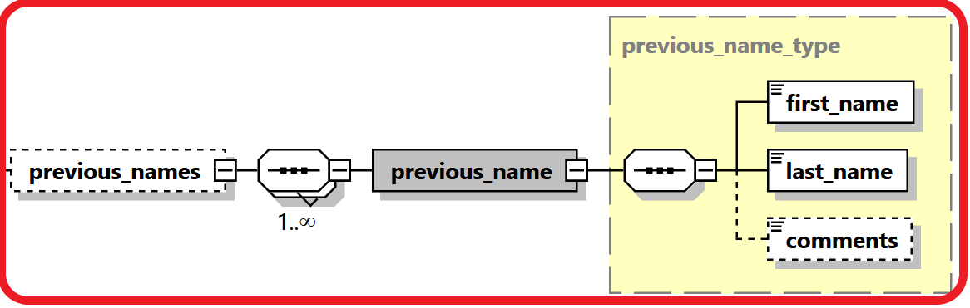

|  |  |  |  |  |  |
| --- | --- | --- | --- | --- | --- |
| Name | #Schema  #App | Description | Length | Req. | Example |
| First_name | Schema 5.0.1  App 5.2 | First Name | 100 | Y |  |
| last_name | Schema 5.0.1  App 5.2 | Last Name | 100 | Y |  |
| comments | Schema 5.0.1  App 5.2 | Generic Comments | Comments Type | N |  |

## 4.3.3 Type Social Account

Introduced in schema 5.0.1, the type will be implemented in goAML Application 5.2 so REs can report social media accounts of the reported person.

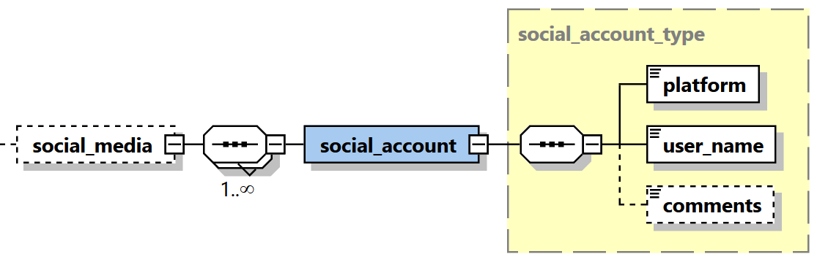

|  |  |  |  |  |  |
| --- | --- | --- | --- | --- | --- |
| **Name** | **#Schema**  **#App** | **Description** | **Length** | **Req.** | **Example** |
| platform | Schema 5.0.1  App 5.2 | Name of social media platform | 255 | Y |  |
| user_name | Schema 5.0.1  App 5.2 | User Name in that social media platform | 255 | Y |  |
| comments | Schema 5.0.1  App 5.2 | Description of the function held by the PEP. | Comments type | N |  |

## 4.3.4 Type Employment History

Introduced in schema 5.0.1, the type will be implemented in goAML Application 5.2 so REs can report many occurrences of employment information including employer name, business, identification, phones, addresses and employment date range. This single one set of employment elements will be deprecated in future Schema releases.

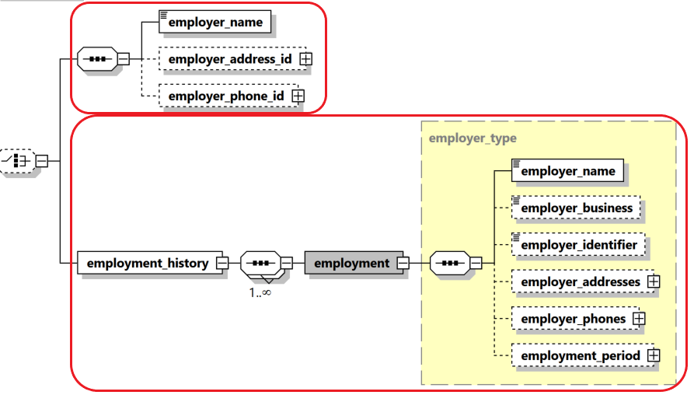

|  |  |  |  |  |  |
| --- | --- | --- | --- | --- | --- |
| **Name** | **#Schema**  **#App** | **Description** | **Length** | **Req.** | **Example** |
| employer_name | Schema 5.0.1  App 5.2 | Type of relation | Enumeration | N |  |
| Person | Schema 5.0.1  App 5.2 | Person node | Subnode | N | See 4.3.1 Type t_person_my_client/ t_person |
| relation_date_range | Schema 5.0.1  App 5.2 | The time frame of the relation between the two persons. | Subnode | N | 4.10 Relation Date Range Type |
| comments | Schema 5.0.1  App 5.2 | Description of the function held by the PEP. | Comments type | N |  |

## 4.3.5 Type t_person_identification

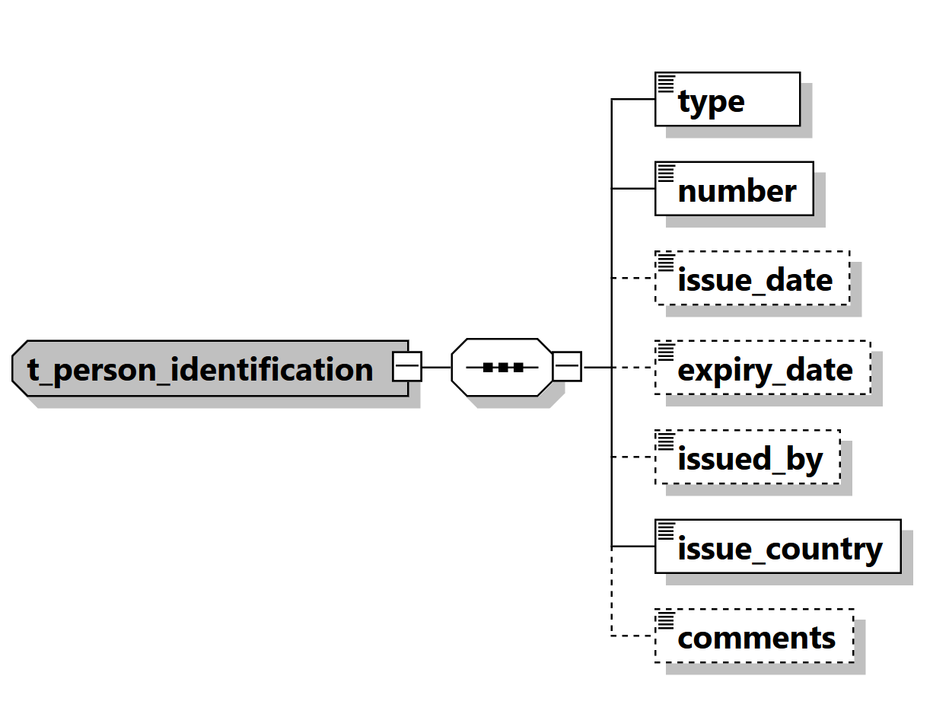

Figure 20: Overview type t_person_identification

|  |  |  |  |  |
| --- | --- | --- | --- | --- |
| **Name** | **Description** | **Length** | **Req.** | **Example** |
| **type** | Document type | Enumeration | **Y** | 5.5 Identifier type |
| **number** | ID of the identification document | 255 | **Y** | AT08154711 |
| issue_date | Identification document issue date | DateTime | N | 2001-12-17T09:30:47 |
| expiry_date | Identification document expiry date | DateTime | N | 2012-01-01T00:00:00 |
| issued_by | Name of Authority issued the document | 255 | N | Interior Ministry |
| **issue_country** | Country where the document was issued | Enumeration | **Y** | See 5.14 Country Codes |
| comments | Generic comments field | 8000 | N |  |

Table 20: Type t_person_identification

## 4.3.6 Type PEPS

Introduced in schema 5.0.1, the type will be implemented in goAML Application 5.2 so REs can indicate if the reported person is/was a Politically Exposed Person with few additional attributes, like country, function name, function description, date range and general comments.

Multiple occurrences of PEP info per person is supported as well.

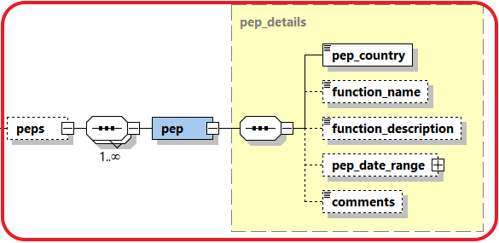

|  |  |  |  |  |  |
| --- | --- | --- | --- | --- | --- |
| **Name** | **#Schema**  **#App** | **Description** | **Length** | **Req.** | **Example** |
| pep_country | Schema 5.0.1  App 5.2 | Name of the related country | Enumeration | Y |  |
| function_name | Schema 5.0.1  App 5.2 | Name of the function held by the PEP. | 255 | N |  |
| function_description | Schema 5.0.1  App 5.2 | Description of the function held by the PEP. | Comments type | N |  |
| pep_date_range | Schema 5.0.1  App 5.2 | The time frame of the subject being PEP in this occurrence. | Subnode | N | 4.10 Relation Date Range Type |
| comments | Schema 5.0.1  App 5.2 | Generic Comments | Comments Type | N |  |

## 4.3.7 Type Person Related Persons

Introduced in schema 5.0.1, the type will be implemented in goAML Application 5.2 so REs can report social network of the reported person.

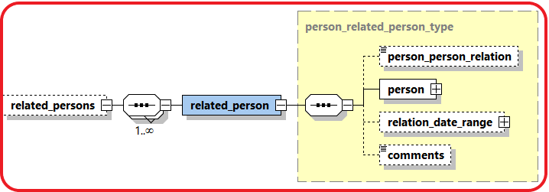

|  |  |  |  |  |  |
| --- | --- | --- | --- | --- | --- |
| **Name** | **#Schema**  **#App** | **Description** | **Length** | **Req.** | **Example** |
| person_person_  relation | Schema 5.0.1  App 5.2 | Type of relation | Enumeration | N | 5.23 Person-Person Relation Type |
| Person | Schema 5.0.1  App 5.2 | Person node | Subnode | N | 4.3.1 Type t_person_my_client/ t_person |
| relation_date_range | Schema 5.0.1  App 5.2 | The time frame of the relation between the two persons. | Subnode | N | 4.10 Relation Date Range Type |
| comments | Schema 5.0.1  App 5.2 | Description of the function held by the PEP. | Comments type | N |  |

## 4.4.1 Type t_person_registration_in_report

The structure of this type is similar to that of type *t_person,* but dedicated to the reporting person details, so FIUs can add some extra restrictions for reporting persons.

## 4.4.2 Type t_conductor/t_conductor_my_client

The structure of these types is similar to that of type *t_person,* but dedicated to the conductor person details, so FIUs can add some extra restrictions for the conducting persons.

## 

## *4.5 Type* t_address

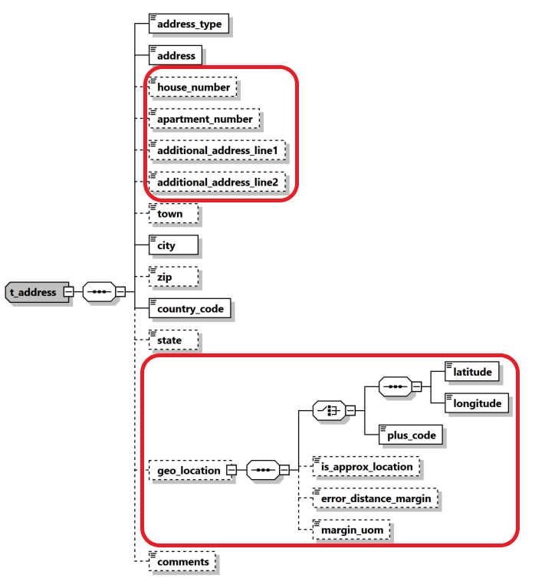

Figure 10: Overview type t_address

|  |  |  |  |  |  |  |  |  |  |  |  |
| --- | --- | --- | --- | --- | --- | --- | --- | --- | --- | --- | --- |
| **Name** | | **#Schema**  **#App** | | **Description** | | **Length** | | **Req.** | | **Example** | |
| **Address_type** | |  | | The contact type of the address | | Enumeration | | **Y** | | Private, Business,..  See 5.9 Contact Type | |
| **Address** | |  | | Street name | | 100 | | **Y** | | - | |
| house_number | | Schema 5.0.1  App 5.2 | | house number | | Integer | | N | | 19 | |
| apartment_number | | Schema 5.0.1  App 5.2 | | Apartment number | | Integer | | N | | 23 | |
| additional_address_line1 | | Schema 5.0.1  App 5.2 | | Additional Address line 1 | | 100 | | N | |  | |
| additional_address_line2 | | Schema 5.0.1  App 5.2 | | Additional Address line 2 | | 100 | | N | |  | |
| Town | |  | | Name of Town/district/.. as part of a City | | 255 | | N | |  | |
| **City** | |  | | City | | 255 | | **Y** | | - | |
| Zip | |  | | Zip Code | | 10 | | N | | A-1220 | |
| **country_code** | |  | | Country | | Enumeration | | **Y** | | See 5.14 Country Codes | |
| State | |  | | State | | 255 | | N | |  | |
| geo_location | | Schema 5.0.1  App 5.2 | | New set of elements to cover the geo location world | | Subnode | | N | |  | |
| latitude | | Schema 5.0.1  App 5.2 | | Address latitude | | Decimal | | N | | 48.210033 | |
| longitude | | Schema 5.0.1  App 5.2 | | Address longitude | | Decimal | | N | | 16.363449 | |
| Plus Code | | Schema 5.0.1  App 5.2 | | Address “Plus Code” | | 25 | | N | | 6CRP+R9 | |
| is_approx_location | | Schema 5.0.1  App 5.2 | | Is the location accurate? | | Boolean | | N | | True | |
| error_distance_margin | | Schema 5.0.1  App 5.2 | | Error margin | | Decimal | | N | | 500 | |
| Margin_uom | | Schema 5.0.1  App 5.2 | | Unit of measurement for error | | 255 | | N | | Meter | |
| comments | |  | | Generic comments | | 8000 | | N | |  | |

able 10: Details type t_address

## 4.6 Type t_phone

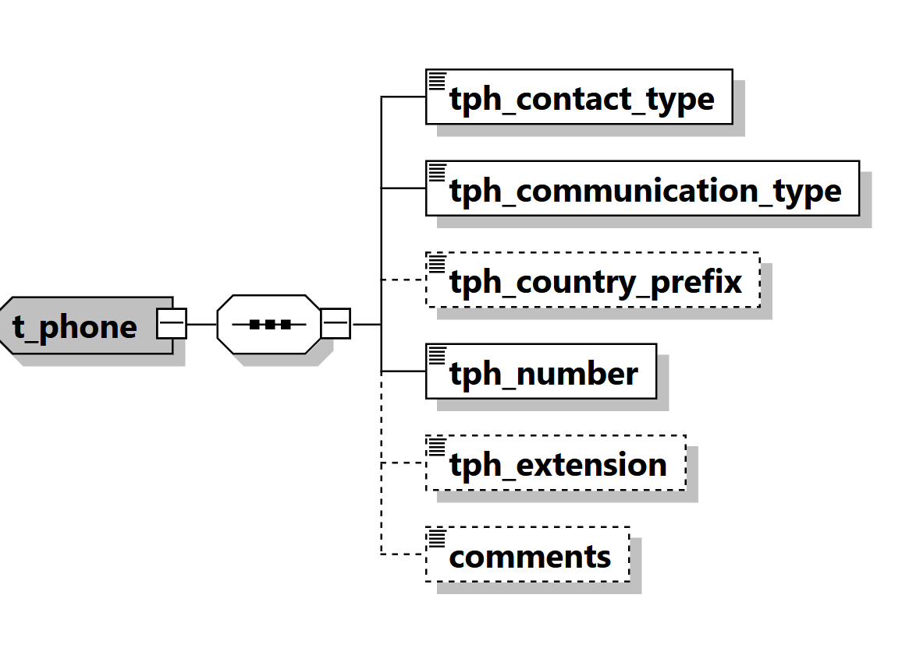

Figure 11: Overview type t_phone

|  |  |  |  |  |
| --- | --- | --- | --- | --- |
| **Name** | **Description** | **Length** | **Req.** | **Example** |
| **tph_contact_type** | The contact type of the Phone | Enumeration | **Y** | Private, Business,..  See 5.9 Contact Type |
| **tph_communication_type** | The comm.. type of the Phone | Enumeration | **Y** | Landline, mobile ,fax,..  5.10 Communication Type |
| tph_country_prefix | Country phone code | 4 | N | 0043 |
| **tph_number** | Phone number | 50 | **Y** | 6655778 |
| tph_extension | Phone’s extension | 10 | N | 7789 |
| comments | Generic comments | 8000 | N |  |

Table 11: Details type t_phone

## 4.7 Type t_foreign_currency

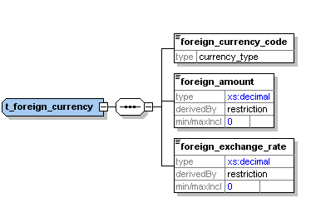

Figure 12: Overview type t_foreign_currency

|  |  |  |  |  |
| --- | --- | --- | --- | --- |
| **Name** | **Description** | **Length** | **Req.** | **Example** |
| **foreign_currency_code** | Currency Code according to ISO 4217 | Enumeration | **Y** | See 5.13 Currencies |
| **foreign_amount** | Transaction amount in foreign currency | Decimal | **Y** | 1300.50 |
| **foreign_exchange_rate** | Exchange rate which has been used for transaction | Decimal | **Y** | 1.45 |

Table 12: Details type t_foreign_currency

## 4.8 Type report_party_type

Introduced in schema 4.0 and enhanced in Schema 5. Represents an involved subject in a report and its details.

Subject can be a Person, an Account or an Entity together with its my_client version in App 5.2 – Only one of them can be included per involved party.

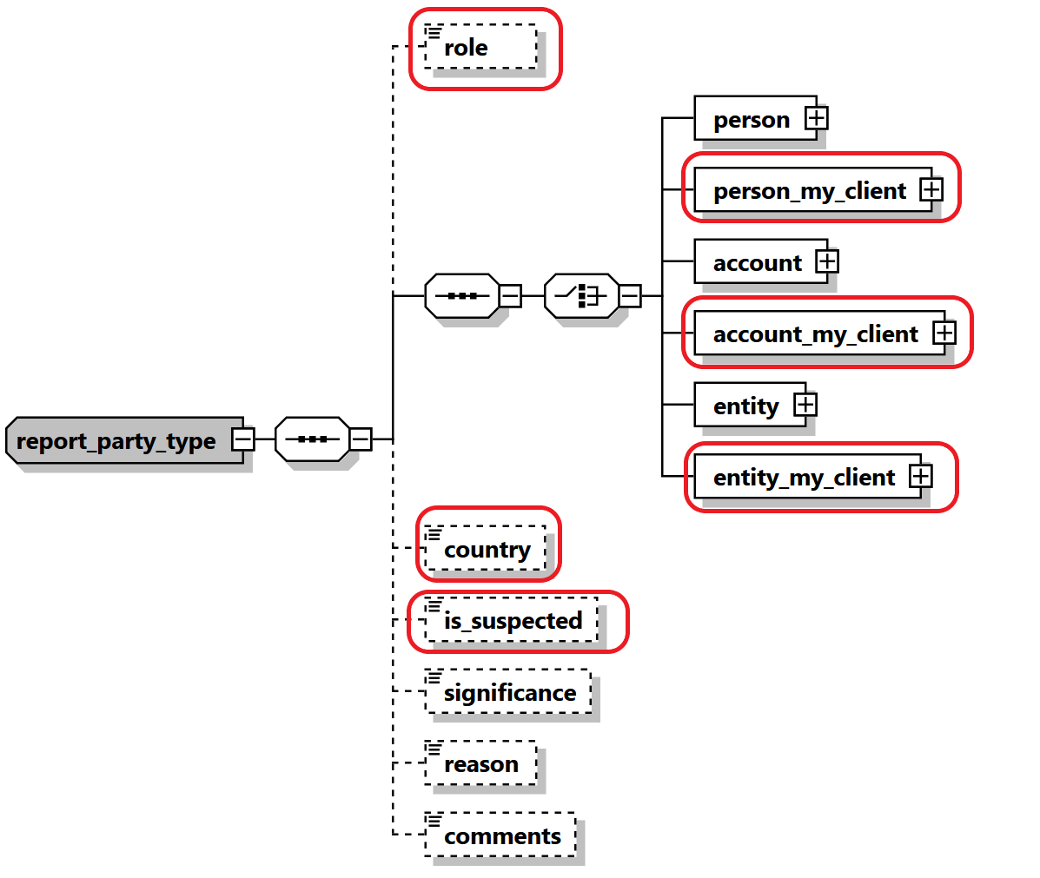

Figure 21: Overview type report_party_type

|  |  |  |  |  |  |  |  |  |  |  |  |  |
| --- | --- | --- | --- | --- | --- | --- | --- | --- | --- | --- | --- | --- |
| **Name** | | | **#Schema**  **#App** | | **Description** | | **Length** | **Req.** | | **Example** | | |
| Role | | | Schema 5.0.1  App 5.2 | | Role of Party in this activity | | Enumeration | N | | Conductor | | |
|  | | One of the following subject nodes must be included when activity node is used | | | | | | | | | | |
| **person** | | |  | | Represents an involved person node | | | t_person type | | **Y** |  |
| **person_my_client** | | | Schema 5.0.1  App 5.2 | | Represents an involved my_client person node | | | t_person_my_client type | | **Y** |  |
| **account** | | |  | | Represents an involved account | | | t_account type | | **Y** |  |
| **Account_my_client** | | | Schema 5.0.1  App 5.2 | | Represents an involved my_client account | | | t_account_my_client type | | **Y** |  |
| **entity** | | |  | | Represents an involved entity | | | t_entity type | | **Y** |  |
| **Entity_my_client** | | | Schema 5.0.1  App 5.2 | | Represents an involved my_client entity | | | t_entity_my_client type | | **Y** |  |
| country | | | Schema 5.0.1  App 5.2 | | The country of the reported party | | Enumeration | N | | UN | | |
| is_suspected | | | Schema 5.0.1  App 5.2 | | Indicates if the party is suspected or not. | | Boolean | N | | True/False | | |
| significance | | |  | | The significance of the subject in the report | | Integer | N | | 0 - 10 | | |
| reason | | |  | | Why the subject is involved in the current report | | 8000 | N | |  | | |
| comments | | |  | | Generic comments element | | 8000 | N | |  | | |

Table 21: Type report_party_type

## 4.9.1 Network Device Type

Introduced in schema 5.0.1, the type is used in goAML Application 5.1 to describe additional information in virtual currency and mobile money transactions regarding the used device and related IP address.

The type will be used in goAML Application 5.2 to allow Reporting Entities like ISP providers to report online connections of their clients if needed.

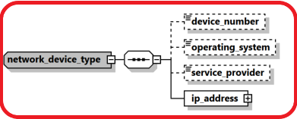

|  |  |  |  |  |  |
| --- | --- | --- | --- | --- | --- |
| **Name** | **#Schema**  **#App** | **Description** | **Length** | **Req.** | **Example** |
| device_number | Schema 5.0.1  App 5.1 | The number of device to send/receive the money in transaction context | 50 | N | 06501234567 |
| operating_system | Schema 5.0.1  App 5.1 | The device operating system | Enumeration | N | iOS, Android, Windows, Mac OS, Linux… |
| service_provider | Schema 5.0.1  App 5.1 | The name of the service provider in case of mobile phone for example | 255 | N | Orange |
| **ip_address** | **Schema 5.0.1**  **App 5.1** | **Describes the details of the used “IP address”** | **Subnode** | **Y** | **See** 4.8.2 IP Address Type |

## 4.9.2 IP Address Type

Introduced in schema 5.0.1, the type is used in goAML Application 5.1 to describe IP address details of the transaction party.

The type will be used in goAML Application 5.2 to allow Reporting Entities like ISP providers to report online connections of their clients if needed.

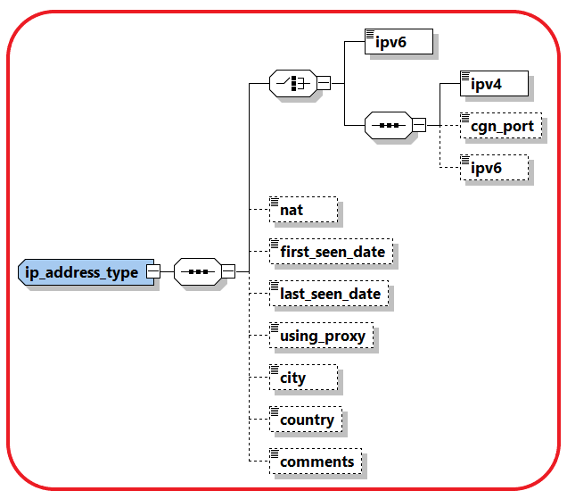

|  |  |  |  |  |  |  |  |  |  |  |  |  |  |  |  |
| --- | --- | --- | --- | --- | --- | --- | --- | --- | --- | --- | --- | --- | --- | --- | --- |
| **Name** | | | **#Schema**  **#App** | | **Description** | | | **Length** | | **Req.** | | | | **Example** | |
| Ipv6 | | | Schema 5.0.1  App 5.1 | | IP address in IPV6 format | | 45 | | | Y | *2001:0db8:85a3:0000:*  *0000:8a2e:0370:7334* | | | | |
| Ipv4 | | | Schema 5.0.1  App 5.1 | | IP address in IPV4 format | | 15 | | | Y | 172.31.255.255 | | | | |
| cgn_port | | | Schema 5.0.1  App 5.1 | | CGN Port | | Integer | | | | N | | 44 | |
| Ipv6 | | | Schema 5.0.1  App 5.1 | | IP address in IPV6 format, can be reported optionally if the main format is ipv4 | | 45 | | | | Y | | *2001:0db8:85a3:0000:*  *0000:8a2e:0370:7334* | |
| Nat | | | Schema 5.0.1  App 5.1 | | [network address translation](https://en.wikipedia.org/wiki/Network_address_translation) | | | 15 | | N | | | | 1.1.1.1 | |
| first_seen_date | | | Schema 5.0.1  App 5.1 | | First time IP address is reported | | | DateTime | | N | | | |  | |
| last_seen_date | | | Schema 5.0.1  App 5.1 | | Last time IP address is reported | | | DateTime | | N | | | |  | |
| using_proxy | | | Schema 5.0.1  App 5.1 | | A flag to indicate if Proxy was used | | | Boolean | | N | | | | True/False | |
| City | | | Schema 5.0.1  App 5.1 | | City name | | | 255 | | N | | | |  | |
| Country | | | Schema 5.0.1  App 5.1 | | Country code | | | Enum | | N | | | |  | |
| Comments | | | Schema 5.0.1  App 5.1 | | Generic Comments | | | 8000 | | N | | | |  | |

## 4.10 Relation Date Range Type

A new type describing relations date range was introduced and is used now with each relation between two nodes in goAML schema. The type is used gradually with each goAML release since 5.0 in combination with implementing the parent type.

The Booleans are considered false by default if not reported.

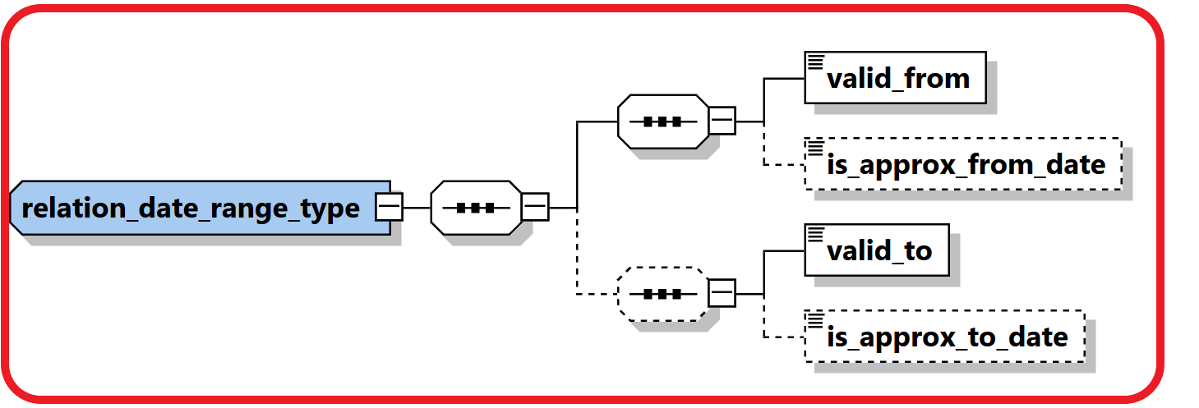

|  |  |  |  |  |  |
| --- | --- | --- | --- | --- | --- |
| **Name** | **#Schema**  **#App** | **Description** | **Length** | **Req.** | **Example** |
| valid_from | Schema 5.0.1  App 5.1 | Valid FROM date | DateTime | Y |  |
| is_approx_from_date | Schema 5.0.1  App 5.1 | Is the “Valid From Date” accurate? | Boolean | N |  |
| valid_to | Schema 5.0.1  App 5.1 | Valid TO Date | DateTime | Y |  |
| is_approx_to_date | Schema 5.0.1  App 5.1 | Is the “Valid To Date” accurate? | Boolean | N |  |

## 4.11 Comments Type

A new **comment_type** was introduced with max length of 8000 chars instead of 4000 as newer versions of SQL server supports longer length now.

All elements like **Comments**, **Reason**, **Action** and **Description** elements all over the schema are defined now using the new type.

## 4.12 Business Relationship

A new subnode was introduced to describe the relation between the reported subjects and the reporting entity, including information regarding the relation type and timeframe. Person and Entities in goAML can have multiple relationships with different reporting entities.

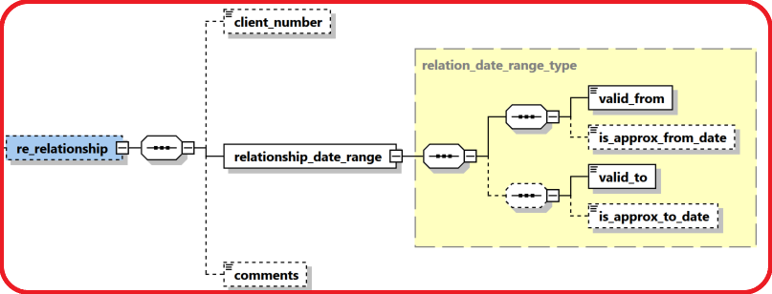

|  |  |  |  |  |  |
| --- | --- | --- | --- | --- | --- |
| **Name** | **#Schema**  **#App** | **Description** | **Length** | **Req.** | **Example** |
| client_number | Schema 5.0.1  App 5.2 | A reference number of the customer at the RE side | 255 | N |  |
| valid_from | Schema 5.0.1  App 5.2 | Valid FROM date | DateTime | Y |  |
| is_approx_from_date | Schema 5.0.1  App 5.2 | Is the “Valid From Date” accurate? | Boolean | N |  |
| valid_to | Schema 5.0.1  App 5.2 | Valid TO Date | DateTime | Y |  |
| is_approx_to_date | Schema 5.0.1  App 5.2 | Is the “Valid To Date” accurate? | Boolean | N |  |
| comments | Schema 5.0.1  App 5.2 | Generic Comments | Comments Type | N |  |

## 4.13 Additional Information

A new optional generic node for adding any number of unplanned extra information in a controlled way. FIUs can introduce new types of additional info and use the appropriate value field(s) for it. The node will be implemented in goAML release 5.2 for Reports, Persons, Accounts and Entities.

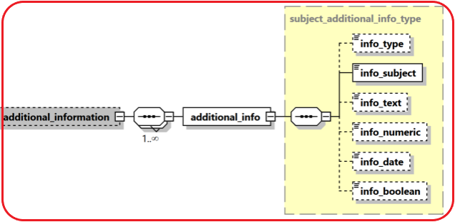

|  |  |  |  |  |  |
| --- | --- | --- | --- | --- | --- |
| **Name** | **#Schema**  **#App** | **Description** | **Length** | **Req.** | **Example** |
| info_type | Schema 5.0.1  App 5.2 | Type of the provided info | Enumeration | N |  |
| Subject | Schema 5.0.1  App 5.2 | Short description of the additional info | 255 | Y |  |
| Info_text | Schema 5.0.1  App 5.2 | A text value of the provided info | Comments type | N |  |
| Info_numeric | Schema 5.0.1  App 5.2 | A numeric value of the provided info | decimal | N |  |
| info_date | Schema 5.0.1  App 5.2 | A date value of the provided info | Date Time | N |  |
| Info_boolean | Schema 5.0.1  App 5.2 | A Boolean value of the provided info | Boolean | N |  |

## 4.14 Sanctions Node

New sanctions node was added which supports multi occurrence of “sanction list”. Each Sanction list contains several details about the list like providing source, list name, matching criteria, date of joining/exiting a list, .etc. The node will be implemented for Persons, Accounts and Entities and will be supported in goAML Release 5.2

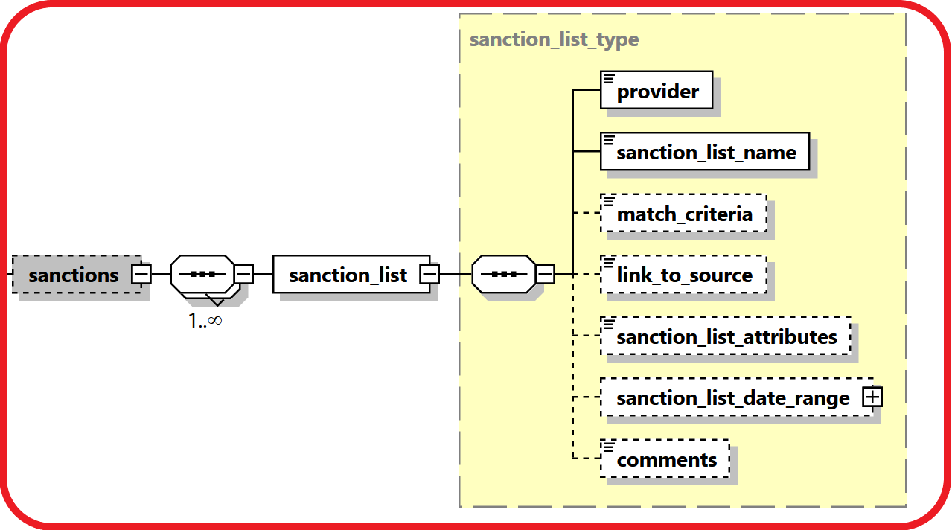

|  |  |  |  |  |  |
| --- | --- | --- | --- | --- | --- |
| **Name** | **#Schema**  **#App** | **Description** | **Length** | **Req.** | **Example** |
| Provider | Schema 5.0.1  App 5.2 | Name of the sanctions list provider | 255 | N |  |
| sanctions_list_name | Schema 5.0.1  App 5.2 | Name of the sanctions list | 255 | Y |  |
| match_criteria | Schema 5.0.1  App 5.2 | The criteria used by the RE to match the reported subject with the name in the list. | Comments type | N |  |
| link_to_source | Schema 5.0.1  App 5.2 | A link to the subject in the sanction list document | 255 | N |  |
| sanctions_list_attributes | Schema 5.0.1  App 5.2 | Any additional info regarding the subject provided in the sanction list document | Comments type | N |  |
| Sanctions_list_date_range | Schema 5.0.1  App 5.2 | The time frame of the subject existence in the list | Subnode | N | 4.10 Relation Date Range Type |
| comments | Schema 5.0.1  App 5.2 | Generic Comments | Comments Type | N |  |

## 4.15 Means of Transportation Node

A new complex node to capture customs related reports where subjects carry money cross borders as well as possible TBML reporting. The node supports multi routes per transaction with details regarding the reported point, transportation mode (Air, Sea, Road, Train, ..etc.), transportation type (Comm. Airline, Private Jet, Vessel, Cruise Ship, Car, Bus, ..etc.), then step direction, status, date, carrier details as well location details of each route.

Will be supported in goAML Release 5.2

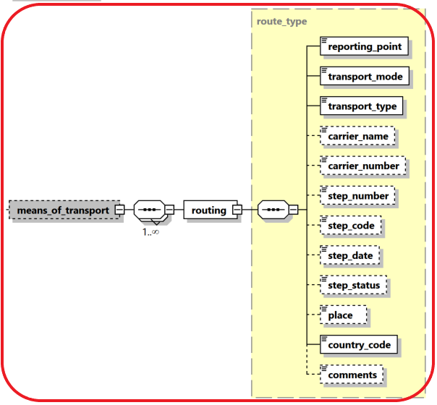

|  |  |  |  |  |  |
| --- | --- | --- | --- | --- | --- |
| **Name** | **#Schema**  **#App** | **Description** | **Length** | **Req.** | **Example** |
| reporting_point | Schema 5.0.1  App 5.2 | Is the report if from this route step? | Boolean | Y |  |
| transport_mode | Schema 5.0.1  App 5.2 | Transportation mode | Enumeration | Y | Air, Sea, Road, Train, |
| transport_type | Schema 5.0.1  App 5.2 | Transportation Type | Enumeration | Y | Comm. Airline, Private Jet, Vessel, Cruise Ship, Car, Bus |
| carrier_name | Schema 5.0.1  App 5.2 | Name of Carrier | 255 | N | UN Airline |
| carrier_number | Schema 5.0.1  App 5.2 | Number of Carrier | 255 | N | UN123 |
| step_number | Schema 5.0.1  App 5.2 | The number of this step in the route | Integer | N |  |
| step_code | Schema 5.0.1  App 5.2 | The code of the step | Enumeration | N | Start, End, Transit,.. |
| step_date | Schema 5.0.1  App 5.2 | Date of the step | DateTime | N |  |
| step_status | Schema 5.0.1  App 5.2 | Status of the step | Enumeration | N | Conducted, Cancelled, .. |
| place | Schema 5.0.1  App 5.2 | Name of the Entry/Exit place | 255 | N | Name of Port, Airport, Border Cross, … |
| country_code | Schema 5.0.1  App 5.2 | Name of step country | Enumeration | Y |  |
| comments | Schema 5.0.1  App 5.2 | Generic Comments | Comments Type | N |  |

# Lookup Values

All schema lookups are defined as enumerations. goAML application includes an option to update the schema automatically with the lookup codes defined by the FIU in the “Lookup Master” screen. Reporting entities cannot submit reports with undefined lookup codes.

Most of the lookup enumerations mentioned below are just suggestions. Feel free to adjust them using “Lookup Master” screen.

## 5.1 Submission type

|  |  |
| --- | --- |
| **Value** | **Description** |
| E | Electronically |
| M | Manually |

Table 13: submission type

## 5.2 Funds type

* The following list is a suggestion. Actual codes defined by FIU in “Lookup Master” will be added automatically to the Schema by goAML client application.

|  |  |
| --- | --- |
| **Value** | **Description** |
| A | Deposit |
| C | Currency exchange |
| D | Casino chips |
| E | Bank draft |
| F | Money order |
| G | Traveler’s cheques |
| H | Life insurance policy |
| I | Real estate |
| J | Securities |
| K | Cash |
| O | Other |
| P | Cheque |

Table 14: Funds type

## 5.3 Account type

*The following list is a suggestion. Actual codes defined by FIU in “Lookup Master” will be added automatically to the Schema by goAML client application.

|  |  |
| --- | --- |
| **Value** | **Description** |
| A | Business |
| B | Personal Current |
| C | Savings |
| D | Trust Account |
| E | Trading Account |
| O | Other |

Table 15: Account type

## 5.4 Account status type

*The following list is a suggestion. Actual codes defined by FIU in “Lookup Master” will be added automatically to the Schema by goAML client application.

|  |  |
| --- | --- |
| **Value** | **Description** |
| A | Active |
| B | Inactive |
| C | Dormant |

Table 16: Account status type

## 5.5 Identifier type

*The following list is a suggestion. Actual codes defined by FIU in “Lookup Master” will be added automatically to the Schema by goAML client application.

|  |  |
| --- | --- |
| **Value** | **Description** |
| A | Driver's license |
| B | Identity Card |
| C | Passport |
| O | Other |

Table 17: Identifier type

## 5.6 Conduction Type

*The following list is a suggestion. Actual codes defined by FIU in “Lookup Master” will be added automatically to the Schema by goAML client application.

|  |  |
| --- | --- |
| **Value** | **Description** |
| A | In-branch/Office |
| B | ATM |
| C | Electronic transaction |
| O | Other |

Table 25: Conduction Type

## 5.7 Transaction Item Status

*The following list is a suggestion. Actual codes defined by FIU in “Lookup Master” will be added automatically to the Schema by goAML client application.

|  |  |
| --- | --- |
| **Value** | **Description** |
| A | Bought |
| B | Sold |
| C | Let |
| D | Hired |
| E | Exchanged |
| F | Donated |
| G | Destroyed |
| H | Other |

Table 26: Transaction Item Status

## 5.8 Report Code

|  |  |
| --- | --- |
| **Value** | **Description** |
| CTR | Cash Transaction Report |
| STR | Suspicious Transaction Report |
| EFT | Electronic Funds Transfer |
| IFT | International Funds Transfer |
| TFR | Terror Financing Report |
| BCR | Border Cash Report |
| UTR | Unusual Transaction Report |
| AIF | Additional Information File – Can be used for example to get full disclosure of transactions of an account for a period of time without reporting it as a CTR. |
| IRI | Incoming Request for Information – International |
| ORI | Outgoing Request for Information – International |
| IRD | Incoming Request for Information – Domestic |
| ORD | Outgoing Request for Information – Domestic |

Table 27: Report Code

## 5.9 Contact Type

*The following list is a suggestion. Actual codes defined by FIU in Lookup Master will be added automatically to the Schema by goAML client application.

|  |  |
| --- | --- |
| **Value** | **Description** |
| B | Business |
| P | Private |
| O | Operational |
| R | Registered |
| - | Unknown |

Table 28: Contact Type

## 5.10 Communication Type

*The following list is a suggestion. Actual codes defined by FIU in Lookup Master will be added automatically to the Schema by goAML client application.

|  |  |
| --- | --- |
| **Value** | **Description** |
| L | Landline Phone |
| M | Mobile Phone |
| F | Fax |
| S | Satellite Phone |
| P | Pager |
| - | Unknown |

Table 29: Communication Type

## 5.11 Entity Legal Form Type

* The following list is a suggestion. Actual codes defined by FIU in “Lookup Master” will be added automatically to the Schema by goAML client application.

|  |  |
| --- | --- |
| **Value** | **Description** |
| A | AG |
| G | GmbH |
| L | Ltd. |
| - | Unknown |

!Unexpected End of Formula

Table 30: Legal Form Type

## 5.12 Transaction Item Type

* The following list is a suggestion. Actual codes defined by FIU in “Lookup Master” will be added automatically to the Schema by goAML client application.

|  |  |
| --- | --- |
| **Value** | **Description** |
| L | Land |
| C | Car |
| - | Unknown |

Table 31: Transaction Item Type

## 5.13 Currencies

World Currencies (and their abbreviations) listed by ISO 4217

|  |  |
| --- | --- |
| ADP | Andorran Peseta (no longer in use) |
| AED | United Arab Emirates Dirham |
| AFA | Afghani |
| ALL | Leek |
| AMD | Dram |
| ANG | Netherlands Antilles Guilder |
| AOK | Kwanza |
| AON | New Kwanza |
| ARA | Austral |
| ARP | Argentinean Peso |
| ARS | Argentinean Nuevo Peso |
| ATS | Schilling (no longer in use) |
| AUD | Australian Dollar |
| AWG | Aruban Guilder |
| AZM | Azerbaijani Manat |
| BAM | Convertible Mark |
| BBD | Barbados Dollar |
| BDT | Taka |
| BEC | Convertible Belgian Franc (no longer in use) |
| BEF | Belgian Franc (also known as Frank - no longer in use) |
| BEL | Financial Belgian Franc (no longer in use) |
| BGL | Lev |
| BHD | Bahraini Dinar |
| BIF | Burundi Franc |
| BMD | Bermudian Dollar |
| BND | Brunei Dollar |
| BOB | Boliviano |
| BOP | Bolivian Peso |
| BRC | Cruzeiro |
| BRL | Real |
| BRR | Cruzeiro Real |
| BSD | Bahamian Dollar |
| BTN | Ngultrum |
| BUK | Replaced by MMK |
| BWP | Pula |
| BYR | Belarussian Rouble |
| BZD | Belize Dollar |
| CAD | Canadian Dollar |
| CDF | Congolese Franc |
| CDZ | New Zaïre |
| CHF | Swiss Franc |
| CLF | Unidades de Fomento |
| CLP | Chilean Peso |
| CNY | Yuan Renminbi |
| COP | Colombian Peso |
| CRC | Costa Rican Colón |
| CSK | Koruna of former Czechoslovakia. Now replaced by CZK (Czech Koruna) and SKK (Slovak Koruna) |
| CUP | Cuban Peso |
| CVE | Escudo Caboverdiano |
| CYP | Cypriot Pound |
| CZK | Czech Koruna |
| DDM | Former East German Mark, DEM subsequently in use |
| DEM | Deutsche Mark (no longer in use) |
| DJF | Djibouti Franc |
| DKK | Danish Krone |
| DOP | Dominican Republic Peso |
| DZD | Algerian Dinar |
| ECS | Sucre (no longer in use) |
| EEK | Kroon |
| EGP | Egyptian Pound |
| ERN | Eritrean Nakfa |
| ESA | Spanish Peseta, Account A (no longer in use) |
| ESB | Spanish Peseta, Account B (no longer in use) |
| ESP | Spanish Peseta (no longer in use) |
| ETB | Ethiopian Birr |
| EUR | Euro |
| FIM | Markka (no longer in use) |
| FJD | Fiji Dollar |
| FKP | Falkland Pound |
| FRF | French Franc (no longer in use) |
| GBP | Pound Sterling (United Kingdom Pound) |
| GEL | Lari |
| GHC | Cedi |
| GIP | Gibraltar Pound |
| GMD | Dalasi |
| GNS | Syli (also known as Guinea Franc) |
| GQE | Ekwele |
| GRD | Greek Drachma (no longer in use) |
| GTQ | Quetzal |
| GWP | Guinea-Bissau Peso |
| GYD | Guyana Dollar |
| HKD | Hong Kong Dollar |
| HNL | Lempira |
| HRD | Croatian Dinar |
| HRK | Croatian Kuna |
| HTG | Gourde |
| HUF | Forint |
| IDR | Rupiah |
| IEP | Punt (no longer in use) |
| ILS | Shekel |
| INR | Indian Rupee |
| IQD | Iraqi Dinar |
| IRR | Iranian Rial |
| ISK | Icelandic Króna |
| ITL | Italian Lira (no longer in use) |
| JMD | Jamaican Dollar |
| JOD | Jordanian Dinar |
| JPY | Yen |
| KES | Kenyan Shilling |
| KGS | Kyrgyzstani Som |
| KHR | Riel |
| KMF | Comorian Franc |
| KPW | Democratic People's Republic of Korean Won |
| KRW | Republic of Korean Won |
| KWD | Kuwaiti Dinar |
| KYD | Cayman Islands Dollar |
| KZT | Tenge |
| LAK | Kip |
| LBP | Lebanese Pound |
| LKR | Sri Lankan Rupee |
| LRD | Liberian Dollar |
| LSL | Loti |
| LSM | Maloti |
| LTL | Litas |
| LUF | Luxembourg Franc (no longer in use) |
| LVL | Lats |
| LYD | Libyan Dinar |
| MAD | Moroccan Dirham |
| MDL | Moldavian Leu |
| MGF | Malagasy Franc |
| MKD | Macedonian Dinar |
| MLF | Malian Franc |
| MMK | Kyat |
| MNT | Tugrik |
| MOP | Pataca |
| MRO | Ouguiya |
| MTL | Maltese Lira |
| MTP | Maltese Pound, replaced by Maltese Lira |
| MUR | Mauritius Rupee |
| MVR | Rufiyaa |
| MWK | Malawian Kwacha |
| MXN | Mexican New Peso (replacement for Mexican Peso) |
| MXP | Mexican Peso, replaced by Mexican New Peso |
| MYR | Ringgit (also known as Malaysian Dollar) |
| MZM | Metical |
| NAD | Namibian Dollar |
| NGN | Naira |
| NIC | Córdoba |
| NLG | Dutch Guilder (no longer in use) |
| NOK | Norwegian Krone |
| NPR | Nepalese Rupee |
| NZD | New Zealand Dollar |
| OMR | Omani Rial |
| PAB | Balboa |
| PEI | Inti |
| PEN | New Sol |
| PES | Sol (replaced by New Sol [PEN]) |
| PGK | Kina |
| PHP | Philippines Peso |
| PKR | Pakistani Rupee |
| PLN | New Zloty |
| PLZ | Zloty (replaced by New Zloty [PLN]) |
| PTE | Portuguese Escudo (no longer in use) |
| PYG | Guarani |
| QAR | Qatari Riyal |
| ROL | Romanian Leu |
| RSD | Serbian Dinar |
| RUB | Russian Federation Rouble (formerly RUR) |
| RWF | Rwandan Franc |
| SAR | Saudi Riyal |
| SBD | Solomon Islands Dollar |
| SCR | Seychelles Rupee |
| SDD | Sudanese Dinar |
| SDP | Sudanese Pound |
| SEK | Swedish Krona |
| SGD | Singapore Dollar |
| SHP | St Helena Pound |
| SIT | Tolar |
| SKK | Slovak Koruna |
| SLL | Leone |
| SOS | Somali Shilling |
| SRG | Surinam Guilder |
| STD | Dobra |
| SUR | Union of Soviet Socialist Republics Rouble |
| SVC | El Salvadorian Colón |
| SYP | Syrian Pound |
| SZL | Lilangeni |
| THB | Baht |
| TJR | Tajik Rouble |
| TMM | Turkmenistani Manat |
| TND | Tunisian Dinar |
| TOP | Pa'anga |
| TPE | Timorian Escudo |
| TRL | Turkish Lira |
| TTD | Trinidad and Tobago Dollar |
| TWD | Taiwan Dollar |
| TZS | Tanzanian Shilling |
| UAH | Hryvna |
| UAK | Karbovanet |
| UGS | Ugandan Shilling |
| UKP | Incorrectly used for GBP |
| USD | United States Dollar |
| USN | United States Dollar (Next day) |
| USS | United States Dollar (Same day) |
| UYP | Uruguayan Peso, replaced by Uruguayan New Peso (UYU) |
| UYU | Uruguayan New Peso |
| UZS | Uzbekistani Som |
| VEB | Bolivar |
| VND | Viet Nam Dông |
| VUV | Vatu |
| WST | Tala |
| XAF | Franc de la Communauté financière africaine |
| XAU | Gold |
| XBA | European Composite Unit |
| XBB | European Monetary Unit |
| XBC | European Unit of Account 9 |
| XBD | European Unit of Account 17 |
| XCD | East Caribbean Dollar |
| XDR | International Monetary Fund Special Drawing Rights |
| XEU | ECU (not an official currency, replaced by the Euro) |
| XOF | West African Franc |
| XPF | Franc des Comptoirs français du Pacifique |
| YDD | South Yemeni Dinar |
| YER | Yemeni Riyal |
| YUD | Yugoslavian New Dinar (no longer in use) |
| ZAL | Rand (financial) |
| ZAR | Rand |
| ZMK | Zambian Kwacha |
| ZRZ | Replaced by CDZ |
| ZWD | Zimbabwe Dollar |

Table 32: Currency Codes

## 5.14 Country Codes

This list states the country names (official short names in English) in alphabetical order as given in ISO 3166-1 and the corresponding ISO 3166-1-alpha-2 code elements.

|  |  |
| --- | --- |
| **Value** | **Description** |
| AD | ANDORRA |
| AE | UNITED ARAB EMIRATES |
| AF | AFGHANISTAN |
| AG | ANTIGUA AND BARBUDA |
| AI | ANGUILLA |
| AL | ALBANIA |
| AM | ARMENIA |
| AN | NETHERLANDS ANTILLES |
| AO | ANGOLA |
| AQ | ANTARCTICA |
| AR | ARGENTINA |
| AS | AMERICAN SAMOA |
| AT | AUSTRIA |
| AU | AUSTRALIA |
| AW | ARUBA |
| AX | ÅLAND ISLANDS |
| AZ | AZERBAIJAN |
| BA | BOSNIA AND HERZEGOVINA |
| BB | BARBADOS |
| BD | BANGLADESH |
| BE | BELGIUM |
| BF | BURKINA FASO |
| BG | BULGARIA |
| BH | BAHRAIN |
| BI | BURUNDI |
| BJ | BENIN |
| BM | BERMUDA |
| BN | BRUNEI DARUSSALAM |
| BO | BOLIVIA |
| BR | BRAZIL |
| BS | BAHAMAS |
| BT | BHUTAN |
| BU | BURMA |
| BV | BOUVET ISLAND |
| BW | BOTSWANA |
| BY | BELARUS |
| BZ | BELIZE |
| CA | CANADA |
| CC | COCOS (KEELING) ISLANDS |
| CD | CONGO, THE DEMOCRATIC REPUBLIC OF THE |
| CF | CENTRAL AFRICAN REPUBLIC |
| CG | CONGO |
| CH | SWITZERLAND |
| CI | COTE D'IVOIRE |
| CK | COOK ISLANDS |
| CL | CHILE |
| CM | CAMEROON |
| CN | CHINA |
| CO | COLOMBIA |
| CR | COSTA RICA |
| CS | SERBIA AND MONTENEGRO |
| CU | CUBA |
| CV | CAPE VERDE |
| CX | CHRISTMAS ISLAND |
| CY | CYPRUS |
| CZ | CZECH REPUBLIC |
| DE | GERMANY |
| DJ | DJIBOUTI |
| DK | DENMARK |
| DM | DOMINICA |
| DO | DOMINICAN REPUBLIC |
| DZ | ALGERIA |
| EC | ECUADOR |
| EE | ESTONIA |
| EG | EGYPT |
| EH | WESTERN SAHARA |
| ER | ERITREA |
| ES | SPAIN |
| ET | ETHIOPIA |
| FI | FINLAND |
| FJ | FIJI |
| FK | FALKLAND ISLANDS (MALVINAS) |
| FM | MICRONESIA, FEDERATED STATES OF |
| FO | FAROE ISLANDS |
| FR | FRANCE |
| GA | GABON |
| GB | UNITED KINGDOM |
| GD | GRENADA |
| GE | GEORGIA |
| GF | FRENCH GUIANA |
| GG | GUERNSEY |
| GH | GHANA |
| GI | GIBRALTAR |
| GL | GREENLAND |
| GM | GAMBIA |
| GN | GUINEA |
| GP | GUADELOUPE |
| GQ | EQUATORIAL GUINEA |
| GR | GREECE |
| GS | SOUTH GEORGIA AND THE SOUTH SANDWICH ISLANDS |
| GT | GUATEMALA |
| GU | GUAM |
| GW | GUINEA-BISSAU |
| GY | GUYANA |
| HK | HONG KONG |
| HM | HEARD ISLAND AND MCDONALD ISLANDS |
| HN | HONDURAS |
| HR | CROATIA |
| HT | HAITI |
| HU | HUNGARY |
| ID | INDONESIA |
| IE | IRELAND |
| IL | ISRAEL |
| IM | ISLE OF MAN |
| IN | INDIA |
| IO | BRITISH INDIAN OCEAN TERRITORY |
| IQ | IRAQ |
| IR | IRAN, ISLAMIC REPUBLIC OF |
| IS | ICELAND |
| IT | ITALY |
| JE | JERSEY |
| JM | JAMAICA |
| JO | JORDAN |
| JP | JAPAN |
| KE | KENYA |
| KG | KYRGYZSTAN |
| KH | CAMBODIA |
| KI | KIRIBATI |
| KM | COMOROS |
| KN | SAINT KITTS AND NEVIS |
| KP | KOREA, DEMOCRATIC PEOPLE'S REPUBLIC OF |
| KR | KOREA, REPUBLIC OF |
| KS | KOSOVO |
| KW | KUWAIT |
| KY | CAYMAN ISLANDS |
| KZ | KAZAKHSTAN |
| LA | LAO PEOPLE'S DEMOCRATIC REPUBLIC |
| LB | LEBANON |
| LC | SAINT LUCIA |
| LI | LIECHTENSTEIN |
| LK | SRI LANKA |
| LR | LIBERIA |
| LS | LESOTHO |
| LT | LITHUANIA |
| LU | LUXEMBOURG |
| LV | LATVIA |
| LY | LIBYAN ARAB JAMAHIRIYA |
| MA | MOROCCO |
| MC | MONACO |
| MD | MOLDOVA, REPUBLIC OF |
| ME | MONTENEGRO |
| MG | MADAGASCAR |
| MH | MARSHALL ISLANDS |
| MK | MACEDONIA |
| ML | MALI |
| MM | MYANMAR |
| MN | MONGOLIA |
| MO | MACAO |
| MP | NORTHERN MARIANA ISLANDS |
| MQ | MARTINIQUE |
| MR | MAURITANIA |
| MS | MONTSERRAT |
| MT | MALTA |
| MU | MAURITIUS |
| MV | MALDIVES |
| MW | MALAWI |
| MX | MEXICO |
| MY | MALAYSIA |
| MZ | MOZAMBIQUE |
| NA | NAMIBIA |
| NC | NEW CALEDONIA |
| NE | NIGER |
| NF | NORFOLK ISLAND |
| NG | NIGERIA |
| NI | NICARAGUA |
| NL | NETHERLANDS |
| NO | NORWAY |
| NP | NEPAL |
| NR | NAURU |
| NU | NIUE |
| NZ | NEW ZEALAND |
| OM | OMAN |
| PA | PANAMA |
| PE | PERU |
| PF | FRENCH POLYNESIA |
| PG | PAPUA NEW GUINEA |
| PH | PHILIPPINES |
| PK | PAKISTAN |
| PL | POLAND |
| PM | SAINT PIERRE AND MIQUELON |
| PN | PITCAIRN |
| PR | PUERTO RICO |
| PS | PALESTINIAN TERRITORY, OCCUPIED |
| PT | PORTUGAL |
| PW | PALAU |
| PY | PARAGUAY |
| QA | QATAR |
| RE | REUNION |
| RO | ROMANIA |
| RS | SERBIA |
| RU | RUSSIAN FEDERATION |
| RW | RWANDA |
| SA | SAUDI ARABIA |
| SB | SOLOMON ISLANDS |
| SC | SEYCHELLES |
| SD | SUDAN |
| SE | SWEDEN |
| SG | SINGAPORE |
| SH | SAINT HELENA |
| SI | SLOVENIA |
| SJ | SVALBARD AND JAN MAYEN |
| SK | SLOVAKIA |
| SL | SIERRA LEONE |
| SM | SAN MARINO |
| SN | SENEGAL |
| SO | SOMALIA |
| SR | SURINAME |
| ST | SAO TOME AND PRINCIPE |
| SV | EL SALVADOR |
| SY | SYRIAN ARAB REPUBLIC |
| SZ | SWAZILAND |
| TC | TURKS AND CAICOS ISLANDS |
| TD | CHAD |
| TF | FRENCH SOUTHERN TERRITORIES |
| TG | TOGO |
| TH | THAILAND |
| TJ | TAJIKISTAN |
| TK | TOKELAU |
| TL | TIMOR-LESTE |
| TM | TURKMENISTAN |
| TN | TUNISIA |
| TO | TONGA |
| TP | EAST TIMOR |
| TR | TURKEY |
| TT | TRINIDAD AND TOBAGO |
| TV | TUVALU |
| TW | TAIWAN, PROVINCE OF CHINA |
| TZ | TANZANIA, UNITED REPUBLIC OF |
| UA | UKRAINE |
| UG | UGANDA |
| UM | UNITED STATES MINOR OUTLYING ISLANDS |
| US | UNITED STATES |
| UY | URUGUAY |
| UZ | UZBEKISTAN |
| VA | HOLY SEE (VATICAN CITY STATE) |
| VC | SAINT VINCENT AND THE GRENADINES |
| VE | VENEZUELA |
| VG | VIRGIN ISLANDS, BRITISH |
| VI | VIRGIN ISLANDS, U.S. |
| VN | VIET NAM |
| VU | VANUATU |
| WF | WALLIS AND FUTUNA |
| WS | SAMOA |
| YE | YEMEN |
| YT | MAYOTTE |
| YU | YUGOSLAVIA |
| ZA | SOUTH AFRICA |
| ZM | ZAMBIA |
| ZR | ZAIRE |
| ZW | ZIMBABWE |

Table 33: Country Codes

## 5.15 Account Person Role Type

* The following list is a suggestion. Actual codes defined by FIU in “Lookup Master” will be added automatically to the Schema by goAML client application.

.

|  |  |
| --- | --- |
| **Value** | **Description** |
| - | Unknown |
| A | Primary Holder |
| B | Beneficial Owner |
| C | Trustee |
| D | Power of Attorney |

## 5.16 Entity Person Role Type

*The following list is a suggestion. Actual codes defined by FIU in “Lookup Master” will be added automatically to the Schema by goAML client application.

.

|  |  |
| --- | --- |
| **Value** | **Description** |
| - | Unknown |
| BO | Beneficial Owner |
| BORDM | Board Member |
| CEO | CEO |
| CFO | Chief Financial Officer |
| DIR | Director |
| MGD | Managing Director |
| TRUST | Trustee |

## 5.17 Entity-Entity Relation Type

*The following list is a suggestion. Actual codes defined by FIU in “Lookup Master” will be added automatically to the Schema by goAML client application.

.

|  |  |
| --- | --- |
| **Value** | **Description** |
| - | Unknown |
| A | Corporate Partnership |
| B | Financial Advisory |
| C | Legal Advisory |
| D | Leadership and Peer Mentor |
| G | Competitor |
| H | Lenders and investors |
| OWN | Owning Company |
| SUB | subsidiary |

## 5.18 Transaction Type

*The following list is a suggestion. Actual codes defined by FIU in “Lookup Master” will be added automatically to the Schema by goAML client application.

.

|  |  |
| --- | --- |
| **Value** | **Description** |
| - | Unknown |
| DEPS | Deposit |
| WTHD | Withdraw |
| TRANS | Online Transfer |
|  |  |

## 5.19 Transaction Status

*The following list is a suggestion. Actual codes defined by FIU in “Lookup Master” will be added automatically to the Schema by goAML client application.

.

|  |  |
| --- | --- |
| **Value** | **Description** |
| - | Unknown |
| C | Complete |
| F | Freeze |
| I | Incomplete |
| P | Processed |
| S | Cancelled |
| U | Uploaded |
|  |  |

## 5.20 Account Category Type

*The following list is a suggestion. Actual codes defined by FIU in “Lookup Master” will be added automatically to the Schema by goAML client application.

.

|  |  |
| --- | --- |
| **Value** | **Description** |
| - | Unknown |
| ACCNT | Account |
| EMAIL | Email |
| IBAN | IBAN |
| MOB | Mobile |
| PYMCC | Payment Card |
| VADDR | Virtual Address |
| VWALT | Virtual Wallet |
|  |  |

## 5.21 Account-Entity Relation Type

*The following list is a suggestion. Actual codes defined by FIU in “Lookup Master” will be added automatically to the Schema by goAML client application.

.

|  |  |
| --- | --- |
| **Value** | **Description** |
| - | Unknown |
| A | Owning Entity |
| B | Trustee |
| C | Notary |

## 5.22 Account-Account Relation Type

*The following list is a suggestion. Actual codes defined by FIU in “Lookup Master” will be added automatically to the Schema by goAML client application.

.

|  |  |
| --- | --- |
| **Value** | **Description** |
| - | Unknown |
| A | Same Private Beneficiary |
| B | Same Owning Company |

## 5.23 Person-Person Relation Type

*The following list is a suggestion. Actual codes defined by FIU in “Lookup Master” will be added automatically to the Schema by goAML client application.

.

|  |  |
| --- | --- |
| **Value** | **Description** |
| - | Unknown |
| SPSE | Spouse |
| CHLD | Child |
| SBL | Sibling |
| PRNT | Parent |

## 5.24 Operating Systems Type

*The following list is a suggestion. Actual codes defined by FIU in “Lookup Master” will be added automatically to the Schema by goAML client application.

.

|  |  |
| --- | --- |
| **Value** | **Description** |
| - | Unknown |
| Android | Android |
| Chrome OS | Chrome OS |
| iOS | iOS |
| Linux | Linux |
| MacOS | MacOS |
| Ubuntu | Ubuntu |
| Windows | Windows |